

***Table of Contents:***

***Subject: Computing for Management***

***Instructor:***

* ***Lab 1:Introduction to Computers/Windows***
* ***Lab 2 : Introduction to Operating Systems and MS DOS***
* ***Lab 3 :Introduction to MS Office Word***
* ***Lab 4 :Introduction to MS Office Word (cont.)***
* ***Lab 5 :Introduction to MS Office Word (cont.)***
* ***Lab 6 : Introduction to MS Office PowerPoint***
* ***Lab 7 : Introduction to MS Office PowerPoint (cont.)***
* ***Lab 8 : Introduction to MS Office PowerPoint (cont.)***
* ***Lab 9 : Introduction to MS Office Excel (Basics)***
* ***Lab 10: Introduction to MS Office Excel (Charts and Pivot Tables)***
* ***Lab 11: Introduction to MS Office Excel (Conditionals and Lookup Tables)***
* ***Lab 12: Introduction to MS Office Excel (Conditional Formatting and Lists)***
* ***Lab 13: Introduction to MS Office Excel (Drop-Down Lists and Dynamic Charts)***
* ***Lab 14: Introduction to MS Office Excel (Interactive Content)***
* ***Lab 15: Introduction to Pseudo codes and Flow Charts***

***LAB 1***

***Introduction to Computers/Windows***

***Objectives:***

1. ***To become familiar with the Windows OS environment***
2. ***To become familiar with the hardware of your computer***

Windows is the most common operating system used for PCs. It is essential that you familiarize yourself with the basic functionality of this OS.

It is necessary that you are aware of the hardware in your computer. While the operating system usually takes care of the complexity of managing the hardware of your computer system, knowing the hardware helps when you have to:

1. Install an operating system
2. Upgrade your computer system
3. Diagnose and repair problems in your computer system

**Lab Tasks:**

**SECTION A**

1. Familiarize yourself with the following basic tasks specific to Windows operating systems.
2. Copying/ pasting a file [select a file, right click> copy; go to the directory to paste into, right click > paste]
3. Creating a new file [hint: right click > new > file type]
4. Creating a new folder [hint: right click > new > folder]
5. Deleting a file [hint: select a file, right click > delete]
6. Finding how to find Windows help [hint: click on Windows Start button, and then on Help and Support, explore what kind of help is available]
7. To check the hardware present in your computer, Right click on My Computer and then click on Properties note down the specifications of the PC you are working on the default tab.

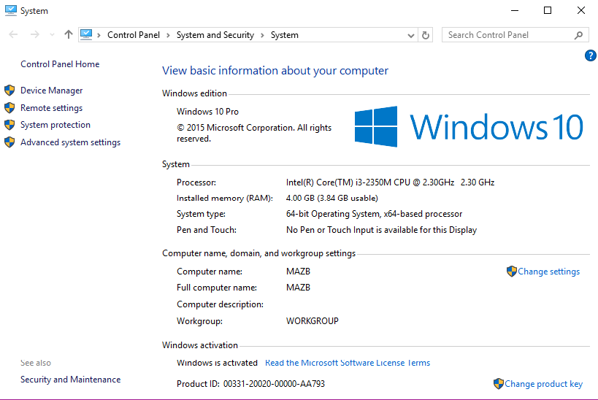

1. *What is the Operating System being used? (write complete details)*
2. *What is the CPU name?*
3. *What is the clock speed of the computer’s CPU?*
4. *What is the amount of RAM present?*
5. *Click on the Remote settings then Computer Name tab*

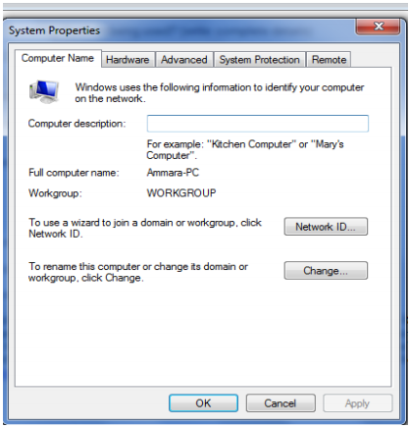

1. What is the computer’s description?
2. What is the computer’s full name?
3. What is the name of computer’s workgroup?

(A workgroup is Microsoft's terminology for a peer-to-peer PC computer network. Machines (with Microsoft operating systems) in the same workgroup may allow each other access to their files, printers, or Internet connection. Members of different workgroups on the same local area network segment and TCP/IP network can only access resources in workgroups to which they are joined.

[[http://en.wikipedia.org/wiki/Workgroup_(Computer_networking)])](%5bhttp:/en.wikipedia.org/wiki/Workgroup_(Computer_networking)%5d))

Now click on the Hardware tab and then on Device Manager, note all information about hardware devices here and answer the following questions?

* 1. What is the name of the disk drive?
  2. Does the computer have a Bluetooth radio?
  3. Does the computer have a network adapter?
  4. What is the name of the monitor? Is the proper driver of the monitor installed?What is the name of the provider of the driver for the monitor?
  5. Find out the name of your hard disk?

**SECTION B**

1. **Practice some keyboard shortcuts**

* F1: Help
* CTRL+ESC: Open Start menus
* ALT+TAB: Switch between open programs
* ALT+F4: Quit program
* SHIFT+DELETE: Delete item permanently
* Windows Logo+L: Lock the computer (without using CTRL+ALT+DELETE)
* CTRL+SHIFT+ESC: Opens Windows Task Manager
* SHIFT+DELETE: Deletes an item immediately without placing it in the Recycle Bin
* Windows Logo: Start menu
* Windows Logo+R: Run dialog box
* Windows Logo+M: Minimize all opened windows
* Windows Logo+F1: Help
* Windows Logo+E: Windows Explorer
* Windows Logo+F: Find files or folders
* Windows Logo+D: Minimizes all open windows and displays the desktop
* Windows Logo+TAB: Cycle through taskbar buttons
* TAB: Move to the next control in the dialog box
* F6: Move the cursor to address bar in internet explorer

1. **What are the key board shortcuts for the following actions?**
   1. Open run dialog box
   2. Open windows explorer
   3. Close the current window
   4. Open search
   5. Minimize all windows
   6. Move the cursor to address bar in internet explorer
   7. Cycle through the taskbar buttons
   8. Opens Windows Task Manager
   9. Lock the computer
   10. Delete an item without placing it in the recycle bin.

***LAB 2***

***Introduction to MS_DOS***

***Objectives:***

1. ***To develop understanding of Operating system basics command line interface through MS DOS.***

**Background**

An operating system (OS) is a collection of software that manages computer hardware resources and provides common services for computer programs. The operating system is an essential component of the system software in a computer system. Application programs usually require an operating system to function. An OS may be command line or GUI (graphical User interface) based.

DOS, short for "Disk Operating System", is a shorthand term for several closely related operating systems that dominated the IBM PC compatible market between 1981 and 1995 or until about 2000 if one includes the partially DOS-based Microsoft Windows versions Windows 95, 98, and Me.

Related systems include MS-DOS, PC-DOS, DR-DOS, Free DOS, PTS-DOS, ROM-DOS, JM-OS, and several others.

In spite of the common usage, none of these systems were named simply "DOS" (a name given only to an unrelated IBM mainframe operating system in the 1960s). A number of unrelated, non-x86 microcomputer disk operating systems had "DOS" in their name, and are often referred to simply as "DOS" when discussing machines that use them (e.g. Amiga DOS, AMSDOS, ANDOS, Apple DOS, Atari DOS, Commodore DOS, CSI-DOS, ProDOS, and TRS-DOS). These were incompatible with DOS executables and the MS-DOS API *.

(*text courtesy: Dr. Junaid Qadir)

**MS DOS Commands**

* Starting DOS Shell
* Click start
* Go to run
* Type ‘cmd.exe’
* Hit Enter

**Some common DOS Commands**

* View the contents of a directory
  + dir
* Creating directory
  + mkdir “directory name” or md “directory name”
* Confirm that newly created directory exist
  + dir “directory name”
* deleting directory
  + rd “directory name"
* Change from one drive to another
  + For example write d: in the command prompt. It will be changed to
  + D :\>. To change back to c drive, write c: in the command prompt.
* Copy files
  + Example copy c:\windows\winhelp.exe c:\sana
* Rename files
  + Example ren twan.dll sana.dll
* Format a floppy disk
  + format drive_name
* Show the Current time
  + Time
* To change from the root directory to the WINDOWS directory
  + cd windows
* To view the list of files in the windows directory
  + dir
  + dir /p (one screen at a time)
* To change to the root directory
  + cd \
* Show the version of the windows
  + Ver

**LAB TASKS**

How are the following operations done in MS DOS? Enter screenshot for every operation

* 1. View the contents of a directory
  2. Create a new directory
  3. Delete a directory
  4. Rename a file in the directory
  5. Change from to root directory to windows directory
  6. View the contents of windows directory
  7. Change from windows directory to root directory
  8. Copy the files from one directory to another
  9. Change from one drive to another
  10. Show the version of windows.
  11. Show help
  12. Show time
  13. Use help command to explore the following.
      + Tree
      + Pause
      + Cls
  14. What does Exit command do?

***LAB 3***

***Introduction to MS Office Word***

***Objectives:***

1. ***To become familiar with word processing and enable students to use the various tools in MS Word effectively to perform common word processing tasks quickly.***

**Microsoft Word**

[**Getting Familiar with Microsoft Word for Windows**](http://www.baycongroup.com/word2007/01_word2007.html)

**Microsoft Word is a word processing** [**software package**](http://www.baycongroup.com/wlesson0.htm)**. You can use it to type letters, reports, and other documents. It gives you the ability to use your home** [**computer**](http://www.baycongroup.com/wlesson0.htm) **as well as your business computer for desktop publishing.**

* [The Microsoft Office Button](http://www.baycongroup.com/word2007/01_word2007.html#button)
* [The Quick Access Toolbar](http://www.baycongroup.com/word2007/01_word2007.html#quickaccess)
* [The Title Bar](http://www.baycongroup.com/word2007/01_word2007.html#titlebar)
* [The Ribbon](http://www.baycongroup.com/word2007/01_word2007.html#ribbon)
* [The Ruler](http://www.baycongroup.com/word2007/01_word2007.html#ruler)
* [The Text Area](http://www.baycongroup.com/word2007/01_word2007.html#text)
* [The Vertical and Horizontal Scroll Bars](http://www.baycongroup.com/word2007/01_word2007.html#bars)
* [The Status Bar](http://www.baycongroup.com/word2007/01_word2007.html#status)
* [Understanding Document Views](http://www.baycongroup.com/word2007/01_word2007.html#view)
* [Click](http://www.baycongroup.com/word2007/01_word2007.html#click)
* [Understanding Nonprinting Characters](http://www.baycongroup.com/word2007/01_word2007.html#options)
* [Create Sample Data and Select Text](http://www.baycongroup.com/word2007/01_word2007.html#highlighting)
* [Place the Cursor](http://www.baycongroup.com/word2007/01_word2007.html#placing)
* [Execute Commands with Keyboard Shortcuts](http://www.baycongroup.com/word2007/01_word2007.html#alt)
* [Start a New Paragraph](http://www.baycongroup.com/word2007/01_word2007.html#paragraph)
* [Exit Word](http://www.baycongroup.com/word2007/01_word2007.html#exit1)
* [Type, Backspace, and Delete](http://www.baycongroup.com/word2007/02_word2007.html#type)
* [Insert and Overtype](http://www.baycongroup.com/word2007/02_word2007.html#insert)
* [Bold, Italicize, and Underline](http://www.baycongroup.com/word2007/02_word2007.html#bold)
* [Save a File and Close Word](http://www.baycongroup.com/word2007/02_word2007.html#save)
* [Open a File](http://www.baycongroup.com/word2007/03_word2007.html#open)
* [Cut and Paste](http://www.baycongroup.com/word2007/03_word2007.html#cut)
* [Copy and Paste](http://www.baycongroup.com/word2007/03_word2007.html#copy)
* [Use Spell Check](http://www.baycongroup.com/word2007/03_word2007.html#spell)
* [Find and Replace](http://www.baycongroup.com/word2007/03_word2007.html#find)
* [Change the Font Size](http://www.baycongroup.com/word2007/03_word2007.html#size)
* [Change the Font](http://www.baycongroup.com/word2007/03_word2007.html#font)
* [Save Your File](http://www.baycongroup.com/word2007/03_word2007.html#save)

**Getting Familiar with Microsoft Word for Windows**

This lesson will introduce you to the Word window. You use this window to interact with Word. To begin this lesson, open Microsoft Word. The Microsoft Word window appears and your screen looks similar to the one shown here.

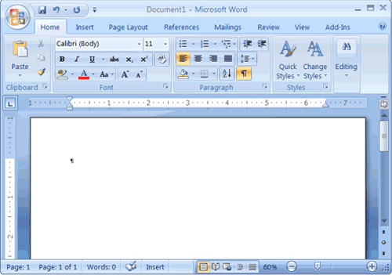

**The Microsoft Office Button**

In the upper-left corner of the Word 2007 window is the Microsoft Office button. When you click the button, a menu appears. You can use the menu to create a new file, open an existing file, save a file, and perform many other tasks.

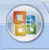

**The Quick Access Toolbar**

Next to the Microsoft Office button is the Quick Access toolbar. The Quick Access toolbar provides you with access to commands you frequently use.



**The Title Bar**

Next to the quick access toolbar is the title bar. The title bar displays the title of the document on which you are currently working.



**The Tabs and Buttons**

After the title bar there are several tabs; clicking a tab displays several related command groups. Within each group are related command buttons. You click buttons to issue commands or to access menus and dialog boxes.

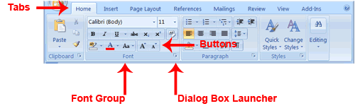

**The Ruler**

The ruler is found below the Ribbon.



You can use the ruler to change the format of your document quickly. If your ruler is not visible, follow the steps listed here:

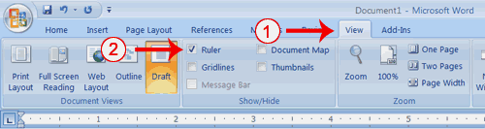

1. Click the View tab to choose it.
2. Click the check box next to Ruler in the Show/Hide group. The ruler appears below the Ribbon.

**The Text Area**

Just below the ruler is a large area called the text area.

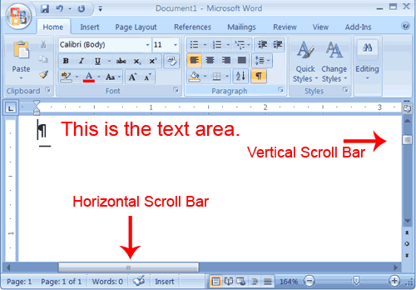

**The Vertical and Horizontal and Vertical Scroll Bars**

The vertical and horizontal scroll bars enable you to move up, down, and across your window simply by dragging the icon located on the scroll bar.

**The Status Bar**

The Status bar appears at the very bottom of your window and provides such information as the current page and the number of words in your document.

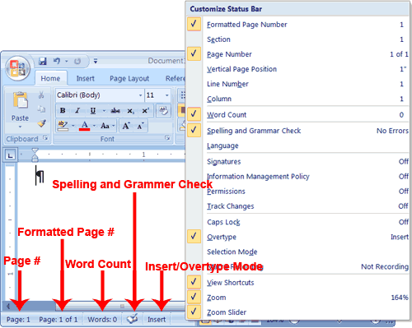

**�****Understanding Document Views**

In Word , you can display your document in one of five views: Draft, Web Layout, Print Layout, Full Screen Reading, or Online Layout.

*Draft View*

Draft view is the most frequently used view. You use Draft view to quickly edit your document.

*Web Layout*

Web Layout view enables you to see your document as it would appear in a browser such as Internet Explorer.

*Print Layout*

The [Print](http://www.baycongroup.com/word2007/01_word2007.html) Layout view shows the document as it will look when it is printed.

*Reading Layout*

Reading Layout view formats your screen to make reading your document more comfortable.

*Outline View*

Outline view displays the document in outline form. You can display headings without the text. If you move a heading, the accompanying text moves with it.

You should use Draft view for these lessons. Before moving ahead, make sure you are in Draft view:

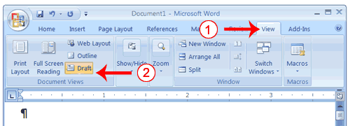

1. Click the View tab.
2. Click Draft in the Document Views group. When the Draft option is selected it appears in a contrasting color.

**Click**

During the lessons that follow, you will be asked to "click" items and to choose tabs. When asked to click:

1. Point to the item.
2. Press your left mouse button once.

If you are asked to double-click an item:

1. Point to the item.
2. Quickly press your left mouse button twice.

If you are asked to right-click:

1. Point to the item.
2. Press your right mouse button.

If you are asked to choose a tab, click the tab.

**Understanding Nonprinting Characters**

Certain characters, called nonprinting characters, do not print and will not appear in your printed document but do affect your document layout.

|  |  |
| --- | --- |
| **Character** | **Denotes** |
| Denotes a tab� | A tab |
| . | A space |
| ¶ | The end of a paragraph |
| Denotes Hidden Text | Hidden text |

To view nonprinting characters:

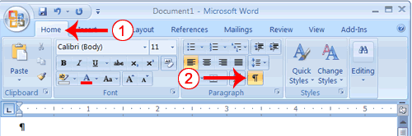

1. Choose the Home tab.
2. Click the Show/Hide button in the Paragraph group . The Show/Hide button appears in a contrasting color, when it is selected.

**Exit Word**

***Close and Save—Windows***

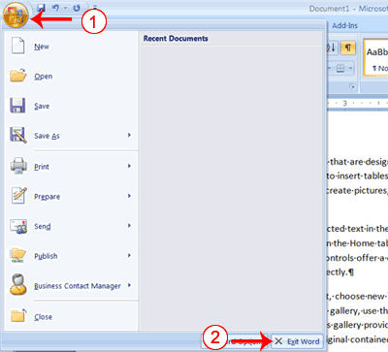

1. Click the Microsoft Office button. A menu appears.
2. Click Exit Word, which you can find in the bottom-right corner.

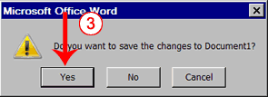

1. You are prompted: "Do you want to save changes to Document1?" To save your changes, click Yes. Otherwise, click No. If you click Yes, the Save As dialog box appears.

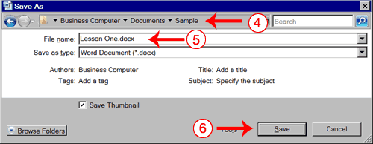

1. Move to the correct folder.
2. Name your file by typing **Lesson One.doc** in the File Name field.
3. Click Save. Word saves your file.

***Close and Save—Windows XP***

1. Click the [Microsoft Office](http://www.baycongroup.com/word2007/01_word2007.html) button. A menu appears.
2. Click Exit Word, which is in the bottom-right corner.
3. You will be prompted: "Do you want to save changes to Document1?" To save your changes, click Yes. Otherwise, click No. If you click Yes, the Save As dialog box appears.
4. Specify the correct folder in the Save In box.
5. Name your file by typing **Lesson One.doc** in the File Name field.
6. Click Save. Word saves your file.

**Type, Backspace, and Delete**

If you want to start a new paragraph, press Enter. Microsoft word creates a blank line to indicate the start of a new paragraph. To capitalize, hold down the Shift key while typing the letter you want to capitalize.  If you make a mistake, you can delete what you typed and then type your correction.

You can use the Backspace key to delete. Each time you press the Backspace key, Microsoft Word deletes the character that precedes the insertion point. The insertion point is the point at which your mouse pointer is located. You can also delete text by using the Delete key. First, you select the text you want to delete; then you press the Delete key.

***EXERCISE 1***

***Type and Backspace***

1. Type the following sentence:   
   **Joe has a very large house.**
2. Delete the word "house." Using either the arrow keys or the mouse, place the cursor between the period and the "e" in "house."
3. Press the Backspace key until the word "house" is deleted.
4. Type **boat**. The sentence should now read:  
   "Joe has a very large boat."

***Delete***

Delete the word "very" from the sentence you just typed.

1. Select the word "very." You can place the cursor before the "v" in the word "very," press and hold down the Shift key, and then press the right arrow key until the word "very" is highlighted.
2. Press the Delete key. The sentence should now read:   
   "Joe has a large boat."

**Insert and Overtype**

While creating your document, you may find you need to insert text—place new text between existing text. Suppose, you type the sentence, "Joe has a large boat."  After typing it, you decide you want to change the sentence to "Joe has a  large *blue* boat." With Microsoft Word, inserting a word, phrase, or even several paragraphs is easy.

**Bold, Italicize, and Underline**

***When creating a document***, you may need to emphasize particular words or phrases by bolding, underlining, or italicizing. Also, certain grammatical constructs require that you bold, underline, or italicize.  You can  bold, underline, and italicize when using Word.

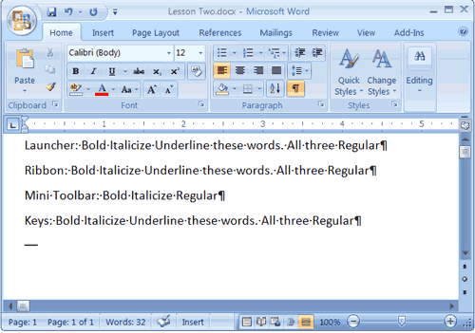  
Your screen should look similar to the one shown here.

***Bold with the Dialog Box Launcher***

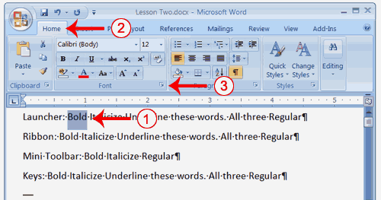

1. On the line that begins with Launcher, select the word "Bold."  You can place the cursor before the letter "B" in "Bold." Press the Shift key; then press the right arrow key until the entire word is highlighted.
2. Choose the Home tab.
3. Click the dialog box launcher in the Font group. The Font dialog box appears.

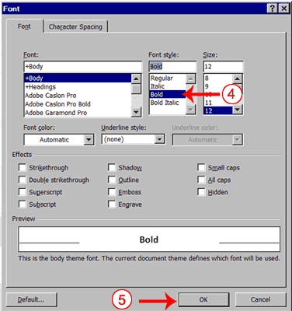

1. Click Boldin the Font Style box.  
   **Note:** You can see the effect of your [action](http://www.baycongroup.com/word2007/02_word2007.html) in the Preview window. To remove the bold, click Regular.
2. Click OK to close the dialog box.
3. Click anywhere in the text area to remove the highlighting. You have bolded the word bold.

***Alternate Method—Bold with the Ribbon***

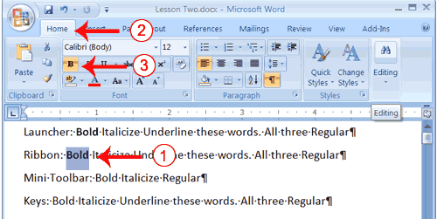

1. On the line that begins with "Ribbon," select the word "Bold."  You can place the cursor before the letter "B" in "Bold." Press the Shift key; then press the right arrow key until the entire word is highlighted.
2. Choose the Home tab.
3. Click the Bold button in the Font group. You have bolded the word bold.  
   **Note:** To remove the bold, you can select the text and then click the Bold button again.
4. Click anywhere in the text area to remove the highlighting.

***Italicize with the Dialog Box Launcher***

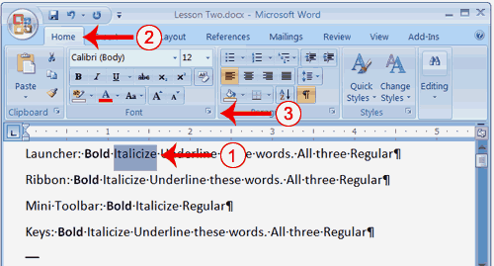

1. On the line that begins with Launcher, select the word "Italicize."  You can place the cursor before the letter "I" in "Italicize." Press the Shift key; then press the right arrow key until the entire word is highlighted.
2. Choose the Home tab.
3. Click the dialog box launcher in the Font group. The Font dialog box appears.

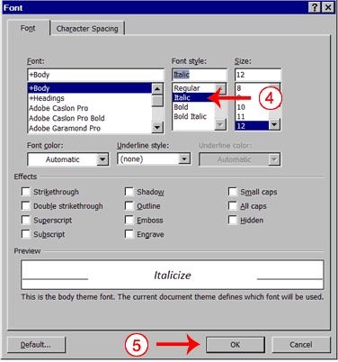

1. Click Italicin the Font Style box.  
   **Note:** You can see the effect of your selection in the Preview window. To remove the italics, click Regular in the Font Style box.
2. Click OK to close the Font dialog box.
3. Click anywhere in the text area to remove the highlighting. You have italicized the word Italicize.

***Alternate Method—Italicize with the Ribbon***

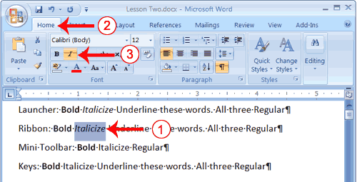

1. On the line that begins with "Ribbon," select the word "Italicize." You can place the cursor before the letter "I" in *"*Italicize." Press the Shift key; then press the right arrow key until the entire word is highlighted.
2. Choose the Home tab.
3. Click the Italic button on the Ribbon. You have italicized the word Italicize.  
   **Note:** To remove the italics, select the text and click the Italicize button again.
4. Click anywhere in the text area to remove the highlighting.

***Underline with the Dialog Box Launcher***

You can underline when using Word. Word provides you with many types of underlines from which to choose.The following are some of the underlines that are available if you use the dialog box launcher:

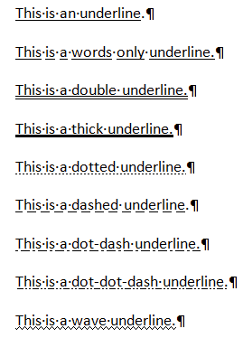

The following illustrates underlining with the dialog box launcher:

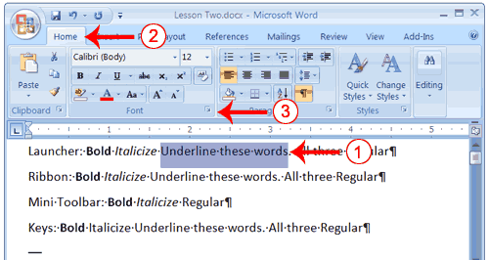

1. On the line that begins with "Launcher," select the words "Underline these words."
2. Choose the Home tab.
3. Click the dialog box launcher in the Font group. The Font dialog box appears.

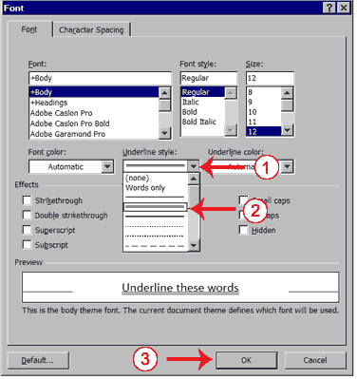

1. In the Underline Style box, click the down arrow to open the pull-down menu.
2. Click the type of underline you wish to use.   
   **Note:** To remove an underline, you select None from the pull-down menu.
3. Click OK to close the dialog box. The underline you selected appears under the words.
4. Click anywhere in the text area to remove the highlighting.

***Alternate Method—Underline with the Ribbon***

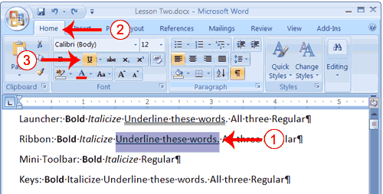

1. On the line that begins with "Ribbon," select the words "Underline these words."
2. Choose the Home tab.
3. Click the Underline button in the Font group . Alternatively, you can press the down arrow next to the underline button and click to choose the type of underline you want.  
   **Note:** To remove the underlining, click the Underline button again.
4. Click anywhere in the text area to remove the highlighting.

**Save a File and Close Word**

You must save your documents if you wish to recall them later. You can use the Save option on the Microsoft Office menu, to save a document. You can also save a document by typing Ctrl+s.

***Save a File—Windows:***

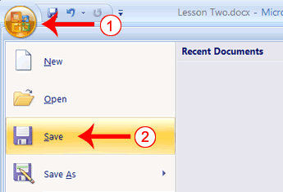

1. Click the Microsoft Office button. A menu appears.
2. Click Save. The Save As dialog box appears, if you are saving your document for the first time.

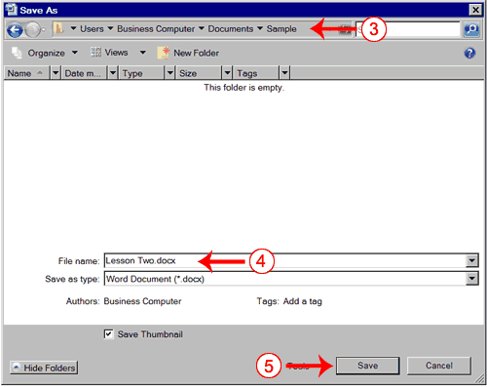

1. Use the Address bar to locate the folder  in which you want to save your file.
2. Name your file by typing **Lesson Two.docx** in the File Name box.
3. Click Save.
4. Click the Microsoft Office button. A menu appears.
5. Click Exit Word, which is located in the bottom-right corner of the window. Word closes.

***LAB 4***

***Introduction to MS Office Word(cont.)***

***Open a File with*** [***Windows***](http://www.baycongroup.com/word2007/03_word2007.html)

If you are using [Windows](http://www.baycongroup.com/word2007/03_word2007.html) :

1. Open Word 2007.
2. Click the Microsoft Office button. A menu appears.
3. Click Open. The Open dialog box appears.
4. Use the Look In field to move to the folder in which you saved the file. The file is named Lesson Two.docx.
5. Click Lesson Two.docx.
6. Click Open. The file you created during the previous lesson appears.

**Cut and Paste**

You can use Word's Cut feature to remove information from a document.  The you can use the Paste feature to place the information you cut anywhere in the same or another document.   In other words, you can move information from one place in a document to another place in the same or different document by using the Cut and Paste features..

***Cut with the Ribbon***

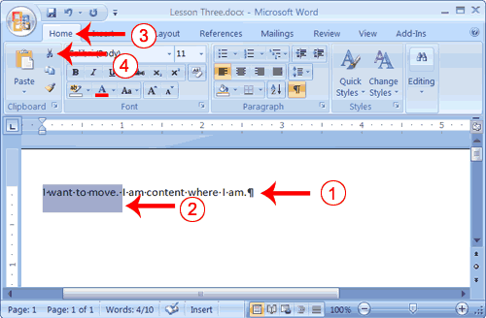

1. Type the following:   
   **I want to move. I am content where I am.**
2. Select "I want to move. "
3. Choose the Home tab.
4. Click the Cut button in the Clipboard group. Word cuts the text you selected and places it on the Clipboard. Your text should now read:   
   "I am content where I am."

***Paste with the Ribbon***

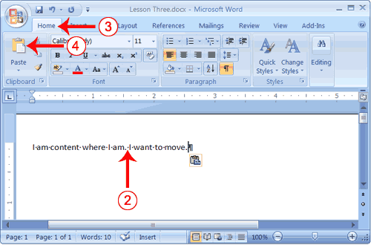

1. Place the cursor after the period in the sentence "I am content where I am."
2. Press the spacebar to leave a space.
3. Choose the Home tab.
4. Click the Paste button in the Clipboard group. Word pastes the text on the Clipboard. Your text should now read:   
   "I am content where I am. I want to move."

***Alternate Method—Cut with a Context Menu***

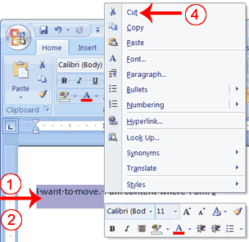

1. Type the following:   
   **I want to move. I am content where I am.**
2. Select "I want to move. "
3. Right-click. The Mini toolbar and a context menu appear.
4. Click Cut on the menu. Your text should now read:   
   "I am content where I am."

***Alternate Method—Paste with a Context Menu***

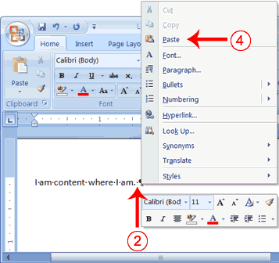

1. Place the cursor after the period in the sentence   
   "I am content where I am."
2. Press the spacebar to leave a space.
3. Right-click. A Mini toolbar and a context menu appear.
4. Click Paste. Your text should now read:   
   "I am content where I am. I want to move."

**Copy and Paste**

In Microsoft Word, you can copy information from one area of a document and place the information you copied anywhere in the same or another document. In other words, after you type information into a document, if you want to place the same information somewhere else, you do not have to retype the information.

***Copy with the Ribbon***

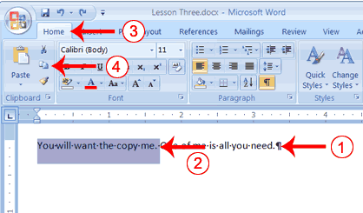

1. Type the following:   
   **You will want to copy me. One of me is all you need.**
2. Select "You will want to copy me."
3. Choose the Home tab.
4. Click the Copy button in the Clipboard group. Word copies the data you selected to the Clipboard.

***Paste with the Ribbon***

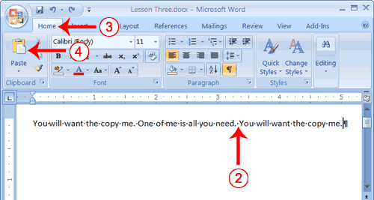

1. Place the cursor after the period in the sentence: "One of me is all you need."
2. Press the spacebar to leave a space.
3. Choose the Home tab.
4. Click the Paste button in the Clipboard group. Word places the data you copied at the insertion point. Your text should now read: "You will want to copy me. One of me is all you need. You will want to copy me."

***Alternate Method—Copy with a Context Menu***

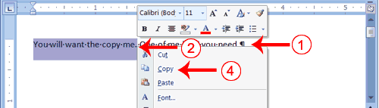

1. Type the following:   
   **You will want to copy me. One of me is all you need.**
2. Select "You will want to copy me."
3. Right-click. A Mini toolbar and a context menu appear.
4. Click Copy. Word places the data you copied at the insertion point. Your text should now read: "You will want to copy me. One of me is all you need. You will want to copy me."

***Alternate Method—Paste with a Context Menu***

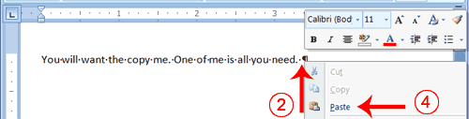

1. Place the cursor after the period in the sentence: "One of me is all you need."
2. Press the spacebar to leave a space.
3. Right-click. A context menu appears.
4. Click Paste. Word pastes the information on the Clipboard into the document.

**Use Spell Check**

Word checks your spelling and grammar as you type. Spelling errors display with a red wavy line under the word. Grammar errors display with a green wavy line under the error. In Word , you can use the Review tab's Spelling & Grammar button to initiate a spell and grammar check of your document.

***Use Spell Check***

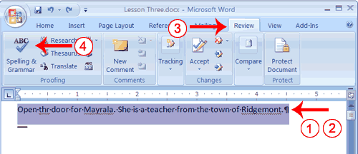

**Find and Replace**

If you need to find a particular word or phrase in your [document](http://www.baycongroup.com/word2007/03_word2007.html), you can use the Find command. This command is especially useful when you are working with large files. If you want to search the entire document, simply execute the Find command. If you want to limit your search to a selected area, select that area and then execute the Find command.

***Use Find with the Ribbon***

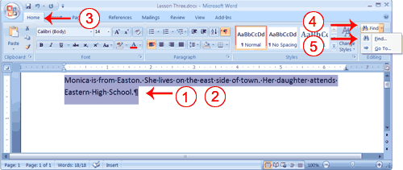

1. Type the following:   
   **Monica is from Easton. She lives on the east side of town. Her daughter attends Eastern High School.**
2. Select: "Monica is from Easton. She lives on the east side of town. Her daughter attends Eastern High School."
3. Choose the Home tab.
4. Click Find in the Editing group. A menu appears.
5. Click the Find option on the menu. The Find and Replace dialog box appears.

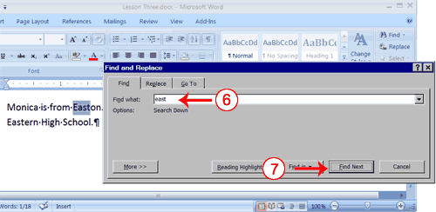

1. Type **east** in the Find What field.
2. Click Find Next.   
   Note that the "East" in Easton is highlighted.
3. Click Find Next again.   
   Note that "east" is highlighted.
4. Click Find Next again.   
   Note that the "East" in Eastern is highlighted.
5. Click Find Next. The following message should appear: "Word has finished [searching](http://www.baycongroup.com/word2007/03_word2007.html) the selection. Do you want to search the remainder of the document?"
6. Click No.
7. Click Cancel.

***Alternate Method—Find with Keys***

1. Select: "Monica is from Easton. She lives on the east side of town. Her daughter attends Eastern High School."
2. Press Ctrl+f.
3. Follow steps 6 through 12 in the preceding section.

**Change the Font Size**

In Microsoft Word, you can change the size of your font. The following exercise illustrates changing the font size.

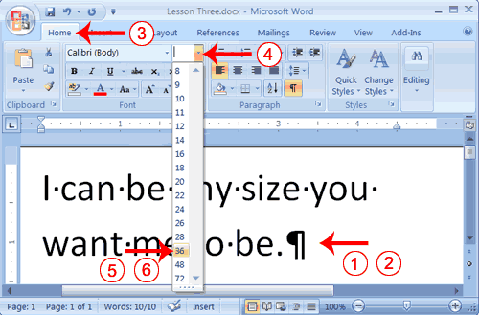

1. Type the following:   
   **I can be any size you want me to be.**
2. Select "I can be any size you want me to be**.**"
3. Choose the Home tab.
4. In the Font group, click the down arrow next to the Font Size box. A menu of font sizes appears.
5. Move your cursor over the menu of font sizes. As you do, Word 2007 provides a live preview of the effect of applying each font size.
6. Click 36 to select it as your font size.

**Note:** If you know the font size you want, you can type it in the Font Size field.

***Alternate Method—Change the Font Size with Grow Font and Shrink Font***

You can also change the size of your font by clicking the Grow Font and Shrink Font buttons.

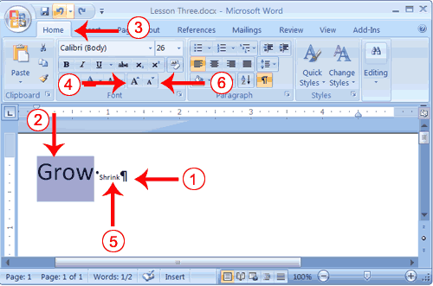

1. Type the following:  
   **Grow Shrink**
2. Select "Grow"
3. Choose the Home tab.
4. Click the Grow Font button several times. You font becomes larger.
5. Select Shrink.
6. Click the Shrink Font button several times. Your font becomes smaller.

***LAB 5***

***Introduction to MS Office Word (cont.)***

**REFERENCE TAB:**

This tab provides the quick way to create table of contents, update it, enter citations or references, choose any writing styles and footnotes etc.

For generating the table of contents first selects the text from the document to appear in it. After selecting the text, make it a heading from “Styles” group in home tab. After making different headings, go to “Table of Contents” option in “Table of Contents” group of “Reference” tab and select any one format.

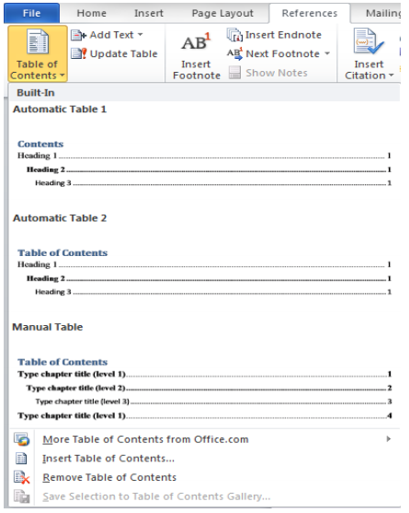

In “Footnotes” group there is an option to add footnotes and endnotes. Footnotes and endnotes are an easy way to add or provide the reader with supplementary information and that information will appear at the end of the page.

To insert a footnote or endnote, navigate to Footnotes section. To insert a footnote, click the menu option with text as **AB1Insert** (Placeholder1) Footnote.

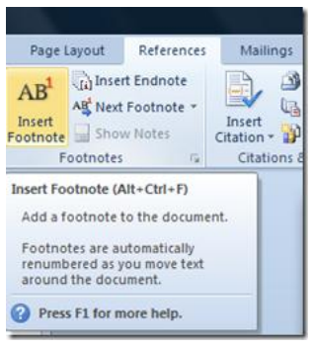

Similarly to insert an endnote, click the Insert Endnote menu option.

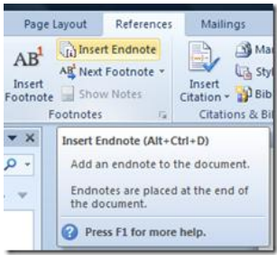

The keyboard shortcuts for inserting a Footnote are Alt + Ctrl + F for inserting an Endnote is Alt + Ctrl + D.

Similarly citations and bibliography can be inserted from “Citations and Bibliography” group. The writing styles can also be changes from here as citations depend upon it. In technical writing we have many different styles of writing that can be select from this group of “Reference” tab.

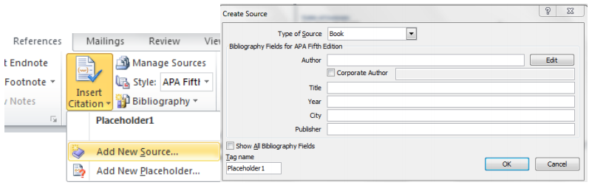

In “Captions” group, one can give captions to the figures and hence can create the table of figures in the same manner as table of content were created.

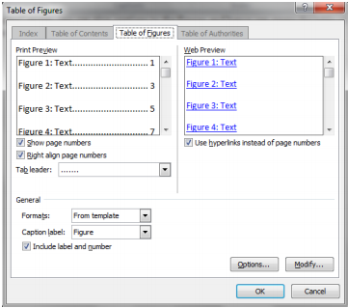

**MAILING TAB:**

We can create and print envelops and labels using this tab. “Start mail merge” are used to create a form letter which one uses for printing and sending purpose. We can select the recipient also.

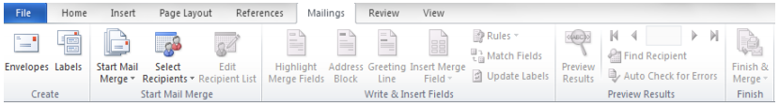

**REVIEW TAB:**

The easiest way to correct spelling mistakes is to right click any word that has a red wavy underline

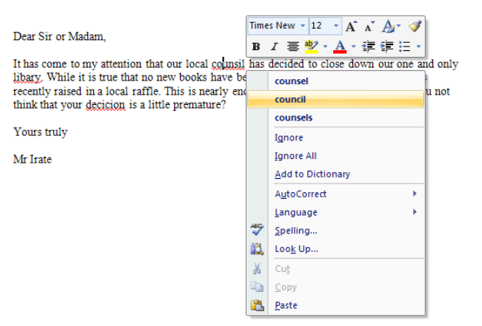

To check more than one word at a time, you can bring up the Spelling and Grammar dialogue box. To see it, click on the Review tab at the top of Word. On the Review tab, locate the Proofing section. Then click Spelling & Grammar:

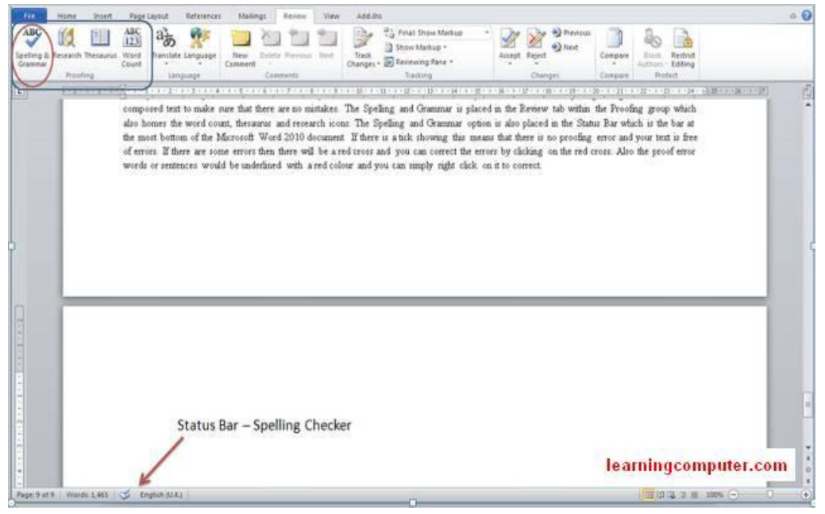

When you click on Spelling & Grammar, you'll see a dialogue box appear. This one:

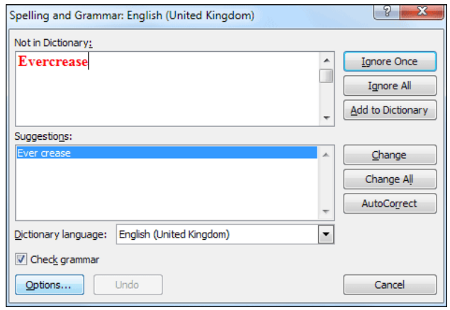

“Spelling and Grammar” option is usually selected once when have compiled all the document and we want it to be correct grammatically also. Word count provides the statistics that how many pages, lines and paragraphs etc. are in our document.

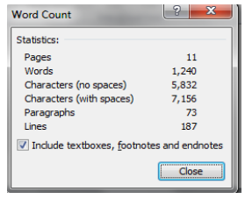

Another way To know the current word count of a document, open the document and right click on the status bar at the bottom of the Word window. The context menu which comes up will have an entry named “Word Count” which will tell you the current word count.

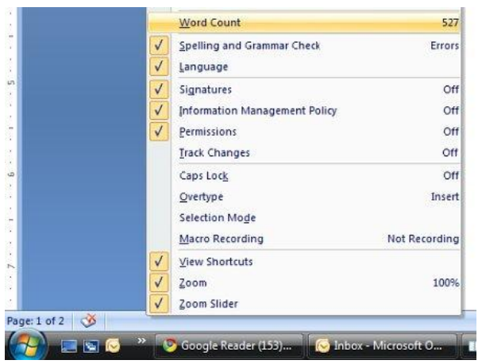

Using “Language” tab one can change the language.

To insert a comment first select the text then go to “New Comment” on “Comments” group in “Review” tab. Click on “New Comment” and a new comment will be inserted. You can also move to next or previous comments and can also delete the comments using this “comments” group.

To insert a comment in a document, highlight the area of text where you want to comment on. Click the Review tab on the Ribbon then click New Comment.

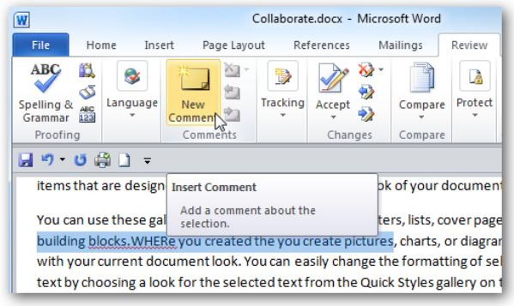

It opens up a balloon pointing to the highlighted text you can leave your comment in.

You can leave as many comments as needed in the document

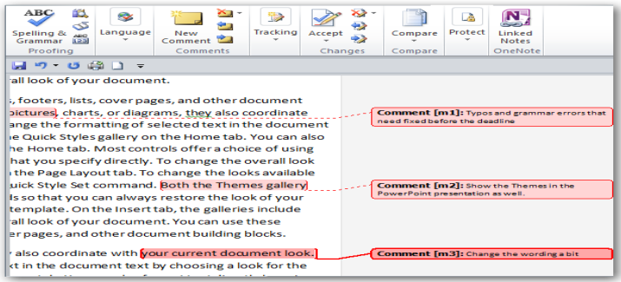

Tracking group:

With this feature of tracking, you can track and view all changes that are made to the document.

1. While in the document, On the Review tab, under the Tracking group, click Track Changes.

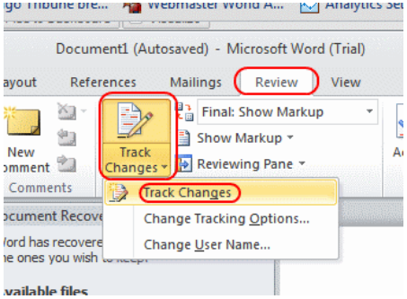

1. On the Review tab, in the Changes section, click the Next button to move to the next change.

2. Click the Accept or Reject button to accept the change or reject the change and move to the next change.

3. Keep going until you’ve responded to all the changes.

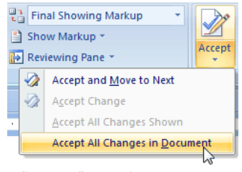

In “Compare” group there is an option to compare two different documents. This option is usually used to find out the similarity between two different documents.

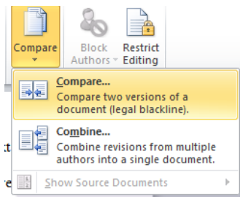

The following window will appear

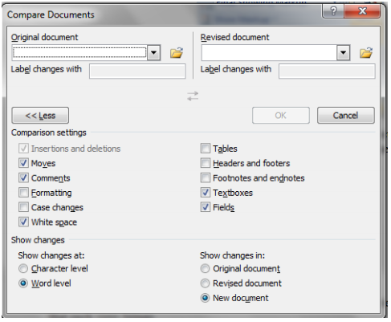

After browsing the paths for original and revised documents click ”ok”. A new document will be opened that will highlight the changes present in the both documents.

**VIEW TAB:**

View tab is used to change the document views. Go through each view and observe the changes that each view brings.

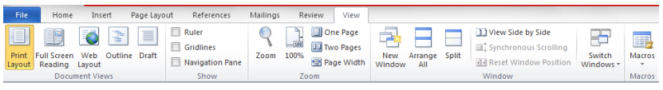

With MS Word 2010 there is also Quick Access Toolbar which has a save, undo Repeat Typing button and Customize Quick Access drop down list. Within the list there are New, Open, Save, E-mail, Quick Print, Print Preview and Print, Spelling & Grammar, Undo, and Redo, Draw Table, Open Recent File icons.

You can also choose to show the Quick Access Toolbar below the Ribbon by choosing Show below the Ribbon selection and you can also customize further with the More Commands button and make Microsoft Word 2010 suitable to your preferences and needs. In such a manner Quick Access Toolbar of MS Word lets you performance routine tasks much faster.

The Microsoft Word 2010 Quick Access toolbar and its functionality are shown below.

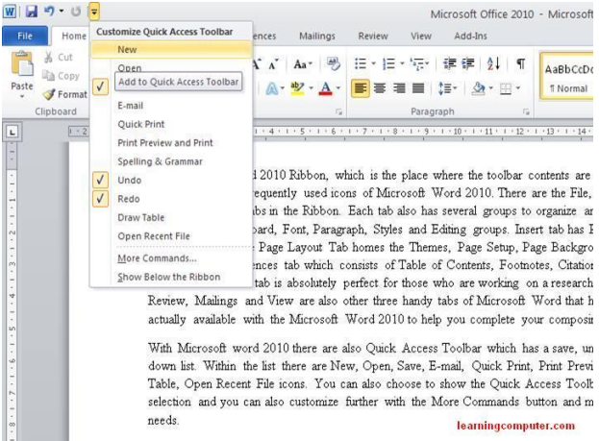

**LAB TASKS**

1. Create the following structure in MS Word

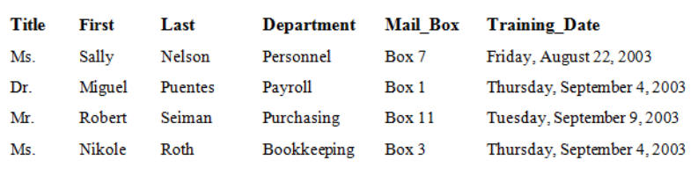

1. A computer is a device that accepts information (in the form of digitalized data) and manipulates it for some result based on a program or sequence of instructions on how the data is to be processed.

Complex computers also include the means for storing data (including the program, which is also a form of data) for some necessary duration. A program may be invariable and built into the computer (and called logic circuitry as it is on microprocessors) or different programs may be provided to the computer (loaded into its storage and then started by an administrator or user). Today's computers have both kinds of programming.

1. Copy the above text and paste in y0ur document.

2. Copy the last sentence today’s computers have both kinds of programming to the beginning of the first paragraph.

3. Change the typeface of the entire document to 11 point Verdana.

4. Change all the word occurrences of computer to workstation.

5. Change the spacing of the entire document from single spacing to 1.5.

6. Change the alignment of the entire document to Justify.

7. Set the phrases logic circuitry and microprocessors in Italic.

**3)** Insert table of contents that provides the reference to different tasks.

**4)**  Write your name and registration number and insert footnote that shows your academic qualification.

**5)** Write on any topic of your choice and insert a comment (not more than three lines).

**6)** Practice to compare any two documents and use of “Spelling & grammar”.

***LAB 6***

***Introduction to MS Office Power Point***

***Objectives:***

1. ***This lab will introduce students with different tabs of MS PowerPoint i.e. Home and Insert tabs of MS Word. Different functionalities, provided by these tabs, will be discussed in this lab.***

**Power Point**

Microsoft PowerPoint is a software product used to perform computer-based presentations. There are various circumstances in which a presentation is made: teaching a class, introducing a product to sell, explaining an organizational structure, etc.

**Home Tab:**

To begin Microsoft PowerPoint, go to Start Menu > All Programs > Microsoft Office > Microsoft PowerPoint 2010 .Select PowerPoint Presentation from the Project Gallery if a blank document does not open.

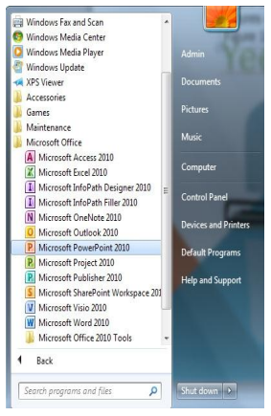

The Design Ribbon toolbar contains several categories for formatting the design and elements of your presentation. These include: Home, Insert, Design, Transitions, Animations, Slide Show, Review and View.

The brief introduction of these tabs is;

* The Home bar: This has features that allow you to edit Slides, Fonts, Paragraph, Drawing and Editing.
* The Insert bar: This has features that allow you to add Tables, Images, Illustrations, Links, WordArt, and Media Clips.
* The Design bar: This allows you to edit how your presentation will look. It includes features such as Page Setup, Themes, and Background Styles.
* The Transitions bar: This allows you to edit Slide Transitions, Effects, and Transition Timing. The Animations bar: This allows you to add custom animations to your presentation. You can select from Preview, Animations, Advance Animation, and Animation timing.
* The Slide Show bar: This has features that allow you to select how your presentation will be displayed. From here, you can start your Slide Show, Set Up your Slide Show, and Adjust Monitor Settings.
* The Review bar: This allows you to Proofread, Translate Languages, Comment Slides, and Compare your Presentation.
* The View bar: This has features that allow you to set the View of your Presentation, Create Master Views, Show/Hide Features, Zoom, Switch from Color to Grayscale, Adjust Windows, and Add Macros.

**Creating a new slide**

1. To create a new slide where you can add content, click the Home tab and select New Slide.

2. Clicking the bottom half of New Slide will give you different new slide options.

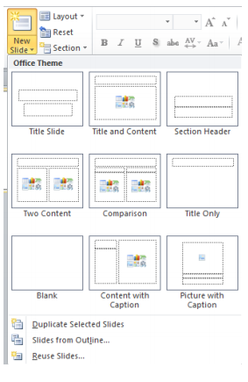

Slide types or layouts include

* title slides
* title and content slides
* comparison slides
* two content
* picture with caption slides
* and more

These layouts of slides will define the appearance of the slide and the way one can put data into the slides.

The layout of the slides can also be change after they are inserted. In Slides group, there is a drop down menu named as “Layout”. By clicking on layout tab and selecting a layout style, the style of current slide can be changed.

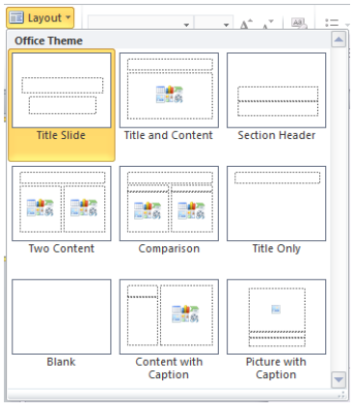

In this tab there is option to cut copy and paste the text. These options are available in “clipboard” group of Home Tab. Shortcut keys for copy, cut and paste commands are Ctrl+c, Ctrl+x and Ctrl+v respectively.

Font group allows you to change the font of the text, size, and case etc. of the text. Select the text first then perform any operation.

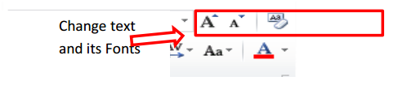

In order to change the case of text, select the text you want to change then go to Font group of Home Tab and choose an option from drop down list.

The simplest way to change the way your text looks is to use Bold, Italics, Underline button on the formatting tool bar. To apply these, just click the button you want your text to be formatted into.

Formatting text involves Underline, Bold, Italic, and Text in different Fonts, Text in different font sizes, and text in different colors.

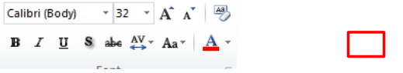

Similarly you can change the text color, outline and appearance etc.

You can make the lists by using bullets, numbering and multilevel list in the “Paragraph Group”.

1. Select the paragraphs you want to format
2. Click the Home tab on the Ribbon and click the Bullets or Numbering button in the paragraph group.

Click the list arrow on each button to apply a different style of bullets or numbering

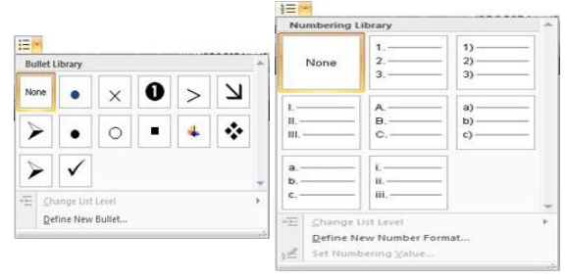

Multileveled lists apply different bullets or numbering to the different levels of a list.

1. Select the paragraphs you want to format
2. Click the Home tab on the Ribbon and click the list arrow on the Multilevel List button in the paragraph group

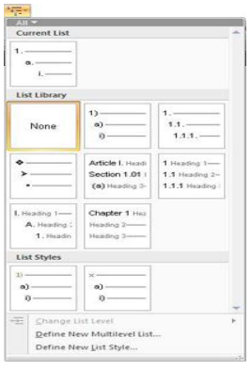

1. Select the style you want to use
2. Change the level of the items in the list by using the Tab key to increase the indent, and by pressing Shift + Tab keys to decrease the indent

Similarly text indentation is also done using this “Paragraph” group.

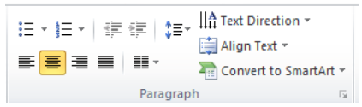

Line and Paragraph Spacing

1. On the home tab of the ribbon, look for the paragraph group. Then click on the Line Spacing button, as shown in the image below.

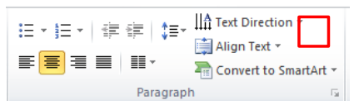

1. Select your desired line spacing. From this menu you can select to have your line spacing set to 1, 1.15, 1.5, 2, 2.5 or 3.

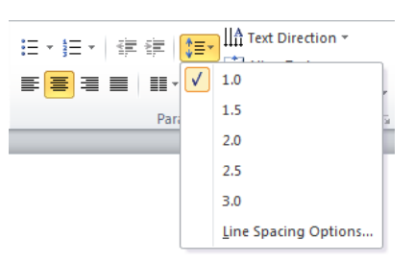

Text direction can also be changed.

* Select the test whose direction is to be changed
* Go to Home tab then in Paragraph group
* Select Text Direction and choose one option from the listed options

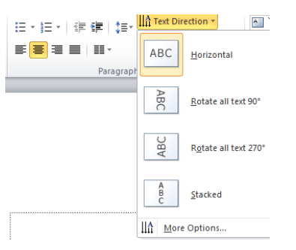

After selecting from Text Direction, the text’s direction will be changed on slide.

To change the alignment of text within the text box, follow the following steps;

* Select the text. Go to Home tab then in “Paragraph” group.
* Click on “Align Text” option. Select any one option.

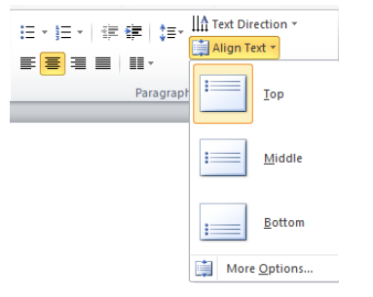

Simple plain text can be converted into SmartArt.

* Select the text. Go to “Home” tab.
* Go to “Paragraph” group and select the “convert to SmartArt” option.
* PowerPoint will list different types of SmartArt graphics.
* You can convert your SmartArt graphic back to text by right-clicking the graphic or SmartArt shape and selecting Convert to Text.
* You will lose some text customizations, such as changes to the text color or font size that you made to the text on the slide when you convert the text to a SmartArt graphic.
* After you select a layout for a SmartArt graphic, the text in your slides is automatically put in shapes and arranged based on the layout that you chose. You can then customize the SmartArt graphic by changing its color or by adding a SmartArt style to it.

You can change the colors applied to the shapes in your SmartArt graphic. The different color combinations are all derived from the theme colors of your presentation.

1. Click the SmartArt graphic.
2. Under SmartArt Tools, on the Design tab, in the SmartArt Styles group, click Change Colors.

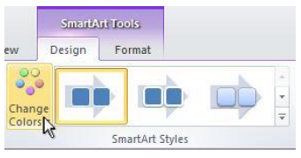

If you don't see the SmartArt Tools or Design tabs, make sure that you've selected a SmartArt graphic. You may have to double-click the SmartArt graphic to select it and open the Design tab.

1. Click the color variation that you want.

The figure shown below states the conversion of the text into SmartArt. It shows how the plain bulleted text is converted into a professional design.

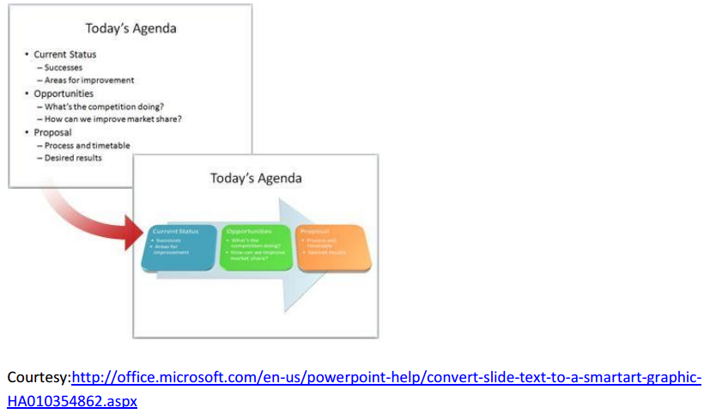

“Drawing” Group of home tab is used to create different type of shapes like square etc.

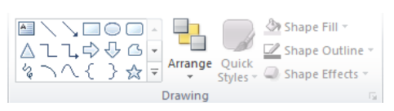

Shape outline, color and effects can be changed using the same group in Home Tab.

Find Replace option in editing group:

1. On the “Home” tab of the Ribbon, go to the “Editing” group, and select “Find”… or use the shortcut key CTRL+F.
2. Type the word you want to find, and then press enter.

If you want to make a change to a specific word, you want to use the replace functionality. To replace a word/s in PowerPoint:

1) Go to the “Editing” group, and select “Replace”, or use the shortcut key CTRL+H

2) In the “Find what” text box, type the word you want to find

3) In the “Replace with” text box, type the word that you want to replace the original word with

4) To replace words one at a time, click “Replace”, if you want to replace every occurrence of the word in the document, click “Replace All”

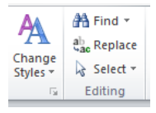

***LAB 7***

***Introduction to MS Office Power Point (cont.)***

**Insert Tab:**

First group in insert tab is “Tables”. On selecting the “table”, different option will appear from where rows and columns can be selected.

* Click on the arrow underneath **Table**. This will open up a new box with several options for creating a table.
* If you select the **Insert Table** option, a dialog box will appear where you can enter more exact specifications for the table.

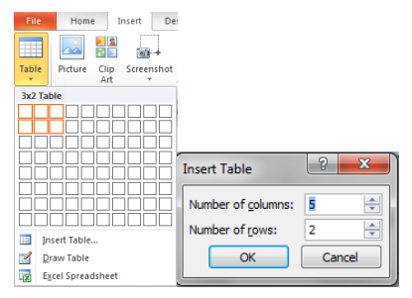

Next group is “Images” group. Any picture placed in any directory of the computer can be accessed using “Picture” option of this group and can be inserted in slides. Similarly Clipart can also be inserted using this group.

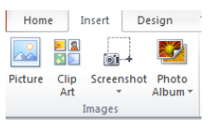

It has an option of getting Screenshots. PowerPoint will automatically take the screenshots of already opened windows and gives the option to select the screenshot and insert in slide.

To create a photo album

* Go to “Images” group of “Insert” tab.
* Click on the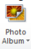. It will give an option to create a new album or edit the existing one.
* On clicking the new photo album the dialogue box is opened

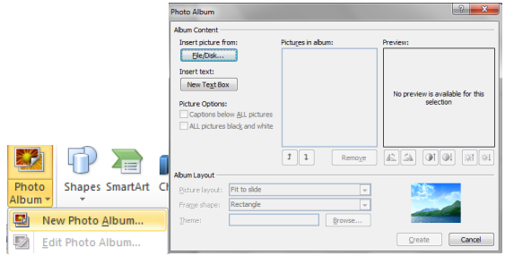

* On selecting multiple files for album a new presentation will be generated having all those selected pictures.

Shapes, SmartArt and charts can be inserted using the “Illustrations” group of the “Insert” tab.

Adding Audio / Video to PowerPoint presentation:

1. Click on the Insert tab of the ribbon.
2. Click on the Movie or sound button in the media clip group to insert video or audio in presentation.
3. There are different options available for inserting audio or video to powerpoint slides.
4. If you want to hide the audio file during slide show, select “Automatically” from Play sound drop down menu and check the Hide during show option in the sound options group.

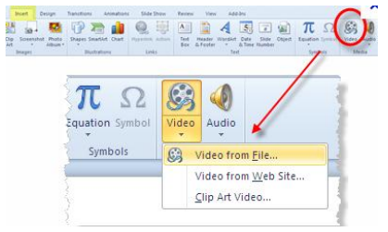

Adding Hyperlink:

Select the text or image to link to insert a hyperlink. From right-click menu, click Hyperlink option

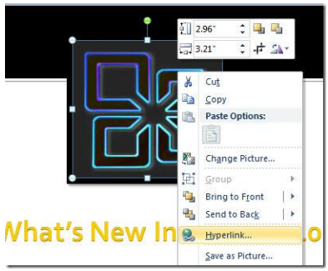

This will bring up Insert Hyperlink dialog, from left side bar, select place in This Document, from center pane, select a slide to create link with and click OK.

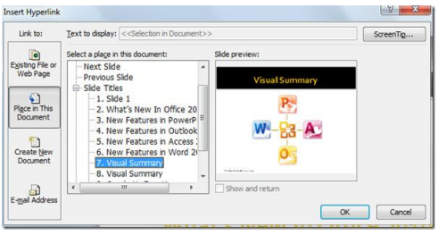

This will insert a hyperlink in a specified slide.

Using “Text” group of “Insert” tab we can insert different text boxes, slide number and word art etc.

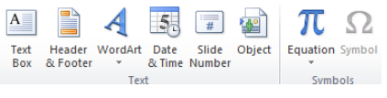

Similarly different equations can be inserted or created in the slide.

**Task 1:**

**Create Photo Album & Hyperlink**

* Insert one new slide and put a text for example: “My Photo Album”
* Create one photo album and adjust your text and your photos
* Save your photo album with a new file
* Make a hyperlink to your photo using the text “My Photo Album”

**Task 2:**

Convert the following SmartArt into plain text and write down how you did this.

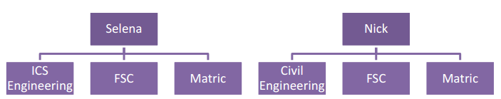

**Task 3:**

Insert the screenshot of current slide using “Images” group.

**Task 4:**

Insert the following equation

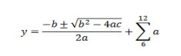

**Task 5:**

Insert the slide number, footer (your merit number) and date.

**Task 6:**

Write your name and rotate it to 270o.

***LAB 8***

***Introduction to MS Office PowerPoint (cont.)***

[**The PowerPoint Window**](http://www.baycongroup.com/powerpoint2007/01_powerpoint.htm)

**PowerPoint is a presentation software package. With PowerPoint, you can easily create slide shows.**

## ****Animations, Transitions, Spell Check, Outline Tab, Slides Tab, Sorter View, and Print****ing

Animations control how objects move onto, off of, and around your slides. Transitions control how your presentation moves from one slide to the next.

### Add Animations

You can animate the objects on your PowerPoint slides. PowerPoint provides four types of animations: Entrance, Emphasis, Exit, and Motion Paths. An **Entrance** animation determines the manner in which an object appears on a slide; for example, an object can move onto a slide. An **Emphasis** animation does something to draw attention to an object; for example, the object can become larger. An **Exit** animation determines the manner in which an object leaves a slide; for example, an object can move off a slide. A **Motion** Paths animation determines how an object moves around a slide; for example, an object can move from left to right.

If the Auto Preview box is checked on the Custom Animation pane, PowerPoint provides you with preview of your animation after you create it and each time you modify it. You can also use the Play button on the Custom Animation pane to preview an animation.

To choose an effect:

1. Select the object you want to animate.
2. Choose the Animations tab.
3. Click the Custom Animation button. The Custom Animation pane appears.
4. Click the Add Effect button. A menu appears.
5. Choose the type of effect you want. A submenu appears.
6. Click the effect you want. PowerPoint applies the effect.

To modify an effect:

1. Click the down arrow next to the Start field on the Custom Animations pane and then select the start method you want.
2. Click the down arrow next to the Property field on the Custom Animations pane and the select the property you want. The Property field might be labeled Direction, Size, or some other property.
3. Click the down arrow next to the Speed field on the Custom Animations pane and then select the speed you want to apply to your animation.

To preview the animation, click the Play button on the Custom Animations pane.

#### Add an Animation to a Slide

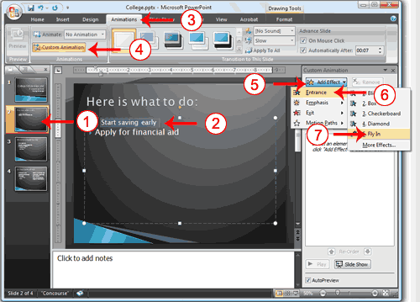

1. Click Slide 2 on the Slides tab.
2. Select "Start saving early."
3. Choose the Animations tab.
4. Click the Custom Animation button. The Custom Animation pane appears.
5. Click the Add Effect button. A menu appears.
6. Choose Entrance. A submenu appears.
7. Click Fly In. PowerPoint applies the effect. If the Auto preview box is checked, PowerPoint automatically provides you with a preview of the animation.

#### Modify the Effect

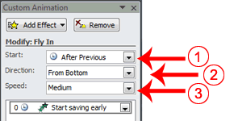

1. Click the down arrow next to the Start field and then select After Previous.
2. Click the down arrow next to the Direction field and then select From Bottom.
3. Click the down arrow next to the Speed field and then select Medium.

#### Add another Animation

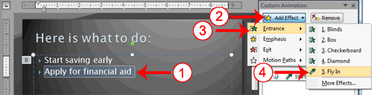

1. Select "Apply for financial aid."
2. Click the Add Effect button. A menu appears.
3. Choose Entrance. A submenu appears.
4. Click Fly In. [PowerPoint](http://www.baycongroup.com/powerpoint2007/03_powerpoint.htm) applies the effect. If the Auto preview box is checked, PowerPoint automatically provides you with a preview of the animation.

#### Modify the Animation

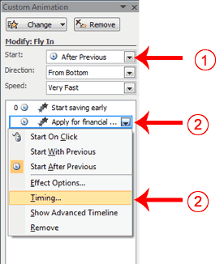

1. Click the down arrow next to the Start field and then select After Previous. The Apply for Financial Aid field appears in the center of the Custom Animation pane.
2. Click the down arrow next to the Apply for Financial Aid field and then click Timing. The Fly In dialog box appears.

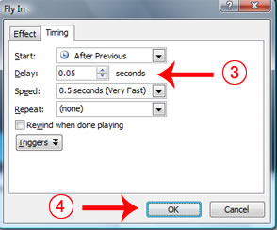

1. Type **0.05** in the Delay text box.
2. Click OK.

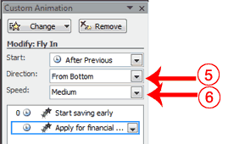

1. Click the down arrow next to the Direction field and then select From Bottom.
2. Click the down arrow next to the Speed field and then select Medium. If the Auto preview box is checked, PowerPoint automatically provides you with a preview of the animation. You can click the Play button on the Custom Animation pane at any time to preview an animation.

### Add Transitions

Transitions determine how your presentations move from one slide to the next. For example, a slide can move up onto the screen and replace the previous slide. PowerPoint provides several transition methods. You can add sound to a transition and you can control its speed. You can apply a transition to selected slides or to all of the slides in your presentation.

A transition can occur when the presenter clicks the mouse or after the amount of time you specify.

To apply a transition to selected slides:

1. On the Slides tab, hold down the Ctrl key and then click the slides to which you want to apply the transition.
2. Choose the Animations tab.
3. Click the More button in the Transition to this Slide group. A menu of transitions appears.
4. Click the transition you want to apply. PowerPoint applies the transition. As you roll your pointer over each transition, PowerPoint provides you with a live preview of the transition.

To apply a transition to all slides:

1. Choose the Animations tab.
2. Click the More button in the Transition to this Slide group. A menu of transitions appears.
3. Click the transition you want to apply. As you roll your pointer over each transition, PowerPoint provides you with a live preview of the transition.
4. Click the Apply to All button in the Transition to This Slide group.

To add a sound to a transition:

1. Choose the Animations tab.
2. Click the down arrow next to the Transition Sound field and then click the sound you want. As you roll your pointer over each sound, PowerPoint plays the sound.

To set the speed of a transition:

1. Choose the Animations tab.
2. Click the down arrow next to the Transition Speed field and then click the speed you want.

#### Add Transitions

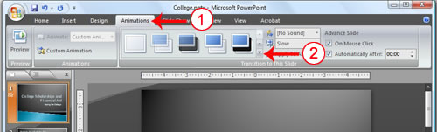

1. Choose the Animations tab.
2. Click the More button in the Transition to this Slide group. A menu of transitions appears.

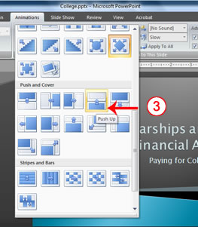s

1. Click the Push Up transition. As you roll your pointer over each transition, PowerPoint provides you with a live preview of the transition.

#### Add Sound and Set the Speed

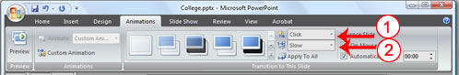

1. Click the down arrow next to the Transition Sound field and then click Click.
2. Click the down arrow next to the Transition Speed field and then click Slow.

#### Advance Slide

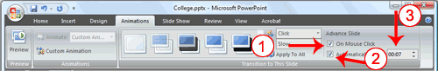

1. Check the On Mouse Click check box.
2. Click the Automatically After check box.
3. Type **00:07** in the Automatically After text box.
4. Click the Apply to All button . PowerPoint applies all of your changes to all of the slides.
5. Click Slide 1 on the Slides tab.
6. Type **00:03** in the Automatically After text box. PowerPoint changes the timing for Slide 1.

### ****Spell Check****

PowerPoint checks your spelling as you type and displays errors with a red wavy line under the misspelled word. You can right-click and then select the correct spelling from the list of offerings on the menu that appears or select Spelling to open the Spelling dialog box. If you need to, you can initiate a spell check anytime you like. To start a spell check, do one of the following:

* Press F7.
* Choose the Review tab and then click the Spelling button.

If the spell check finds a possible spelling error, the Spelling dialog box opens with the spelling error highlighted. You can respond in several ways.

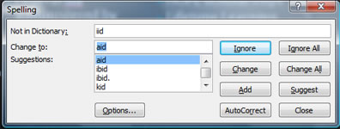

|  |  |
| --- | --- |
| **Response** | **Procedure** |
| Do not change spelling. | Click Ignore. |
| Correct spelling. | 1. Click the correct spelling in the Suggestions box. 2. Click Change. |
| Add to dictionary. | Click Add. |
| Word is correct. Do not change presentation. | Click Ignore All. |
| Word is incorrect. Change entire presentation. | Click Change All. |

#### Spell Check

1. Press F7
2. Correct any spelling errors PowerPoint finds. If PowerPoint does not find any errors, the Spelling Check is Complete message box appears. Click OK.

### Use the Outline and Slides Tabs

By default, the Outline and Slides tabs are located on the left side of your PowerPoint window. The Outline tab displays the text contained in your presentation. The Slides tab displays a thumbnail of all your slides. You click the thumbnail to view the slide in the Slide pane.

#### Use the Outline and Slides Tabs

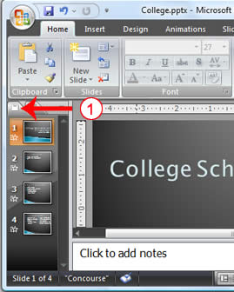

1. Choose the Slides tab to view thumbnails of your slides.

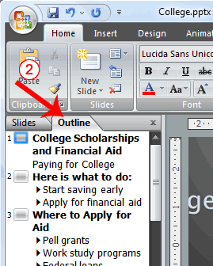

1. Choose the Outline tab to view the text of your presentation as an outline.

### Use Slide Sorter View

After you have created your PowerPoint slides, you can move, cut, copy, paste, duplicate, navigate, and view them in Sorter view. To view the slides in Sorter view, do one of the following:

* Choose the View tab and then click the Slide Sorter button in the Presentation Views group.
* Click the Slide Sorter button in the bottom-right corner of the PowerPoint window.

| **Slide Sorter View** | |
| --- | --- |
| **Task** | **Procedure** |
| Move to first slide. | Use Ctrl+Home. |
| Move to last slide. | Use Ctrl+End. |
| Move to next slide. | Use the right arrow. |
| Move to previous slide. | Use the left arrow. |
| Select a slide. | Single-click the slide. |
| Open a slide in Normal view. | Double-click the slide. |
| Select slides. | Select a single slide:   1. Click the slide you want to select. |
| Select multiple slides:   1. Hold down the Ctrl key. 2. Click the slides you want to select. |
| Delete a slide. | 1. Select the slide or slides you want to delete. 2. Press the Delete key. |
| 1. Select the slide or slides you want to delete. 2. Choose the Home tab and then click the Delete buttonDelete Button. |
| Copy a slide. | 1. Select the slide. 2. Choose the Home tab. 3. Click the Copy button Copy Buttonin the Clipboard group. |
| 1. Select the slide. 2. Press Ctrl+C. |
| Paste a slide. | 1. Select the slide after which you want the new slide or slides to appear. 2. Choose the Home tab. 3. Click the Paste button Paste Buttonin the Clipboard group. |
| 1. Select the slide after which you want the new slide or slides to appear. 2. Press Ctrl+V. |
| Cut a slide. | 1. Select the slide or slides you want to cut. 2. Choose the Home tab. 3. Click the Cut button Cut Buttonin the Clipboard group. |
| 1. Select the slide or slides you want to cut. 2. Press Ctrl+X. |
| Move a slide. | 1. Select the slide (or slides) you want to move. 2. Drag it to the new location. |
| Duplicate a slide. | 1. Select the slide (or slides) you want to duplicate. 2. Press Ctrl+D. |

#### EXERCISE 5

#### Use Slide Sorter View

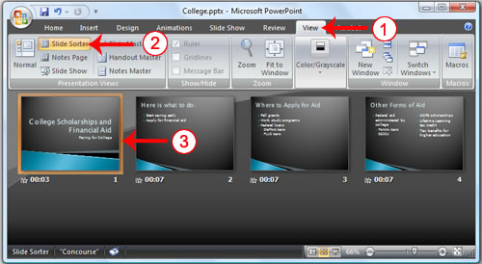

1. Choose the View tab.
2. Click Slide Sorter in the Presentation Views group.
3. Double-click a slide to view it in Normal view.

### Print

PowerPoint provides you with many printing options. You can [print](http://www.baycongroup.com/powerpoint2007/03_powerpoint.htm) a large view of your slides or you can print your slides as handouts with 1, 2, 3, 4, 6, or 9 slides per page. You can also print your Notes pages or the Outline view of your slides.

To print:

1. Click the Microsoft Office button. A menu appears.
2. Choose Print.
3. Click Print Preview.
4. Click the down arrow next to the Print What field in the Page Setup group and then select what you would like to print. A preview appears onscreen.
5. Click the Print . The Print dialog box appears.
6. Click the down arrow next to the Color/Grayscale field to select whether you want your slides to print in color, grayscale, or black and white. If you are using a black and white [printer](http://www.baycongroup.com/powerpoint2007/03_powerpoint.htm), choose black and white. You will use less ink or toner.
7. Click OK.

#### Print an Outline

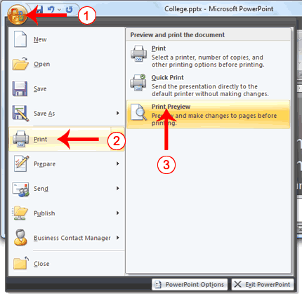

1. Click the [Microsoft Office](http://www.baycongroup.com/powerpoint2007/03_powerpoint.htm) button. A menu appears.
2. Choose Print.
3. Click Print Preview. The Print Preview tab appears.

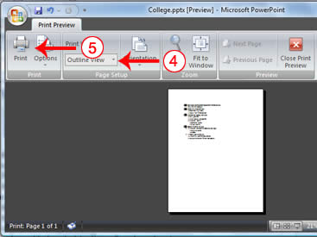

1. Click the down arrow next to the Print What field in the Page Setup group and then select Outline View.
2. Click the Print button. The Print dialog box appears.

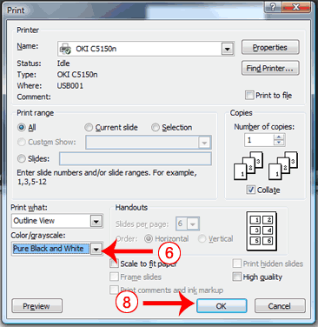

1. Click the down arrow next to the Color/Grayscale field to select whether you want your slides to print in color, grayscale, or black and white. If you are using a black and white printer, choose black and white. You will use less ink or toner.
2. Set the other print settings.
3. Click OK. Your outline prints.

#### Print Your Slides

1. Click the Microsoft Office button. A menu appears.
2. Choose Print.
3. Click Print Preview. The Print Preview tab appears.
4. Click the down arrow next to the Print What field in the Page Setup group and then select Slides.
5. Click the Print button. The Print dialog box appears.
6. Click the down arrow next to the Color/Grayscale field to select whether you want your slides to print in color, grayscale, or black and white. If you are using a black and white printer, choose black and white. You will use less ink or toner.
7. Set the other print settings.
8. Click OK. Your slides print.

#### Print Your Slides as a Handout

1. Click the Microsoft Office button. A menu appears.
2. Choose Print.
3. Click Print Preview. The Print Preview tab appears.
4. Click the down arrow next to the Print What field in the Page Setup group and then select Handouts (4 slides per page).
5. Click the Print button. The Print dialog box appears.
6. Click the down arrow next to the Color/Grayscale field to select whether you want your slides to print in color, grayscale, or black and white. If you are using a black and white printer, choose black and white. You will use less ink or toner.
7. Set the other print settings.
8. Click OK. Your handouts print.

***LAB 9***

***Introduction to MS Office Excel (Basics)***

***Objectives:***

***Microsoft Excel is a tool which has many uses, the most common of which are performing calculations and plotting graphs. This lab will familiarize students with terminology, screen components and the most commonly used functions offered by Microsoft Excel. Emphasis will be placed on file naming and file management conventions.***

***Excel Basics***

Microsoft Excel is a spreadsheet application that is used for basic data organization, statistical analysis, graphing data as well as many other uses. In this lab, we will take a look at what makes up an Excel spreadsheet and the basic uses of it.

**The interface**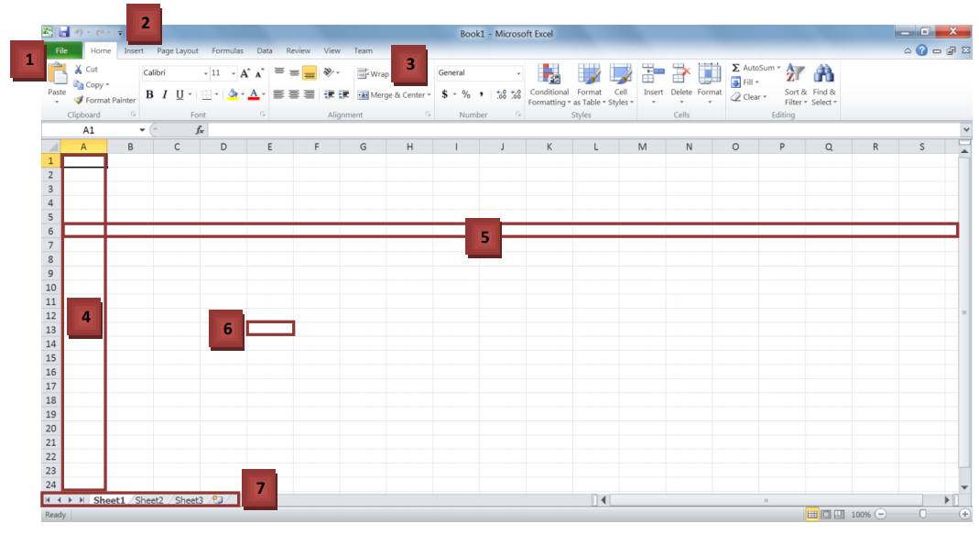

* 1. The File menu: This menu allows you to create, save, open and print spreadsheets.
  2. Quick access toolbar: You can customize this toolbar to include all of the functions you use most, such as save and undo.
  3. The ribbon: The ribbon contains all the office menus and toolbars. The ribbon is divided into tabs, each of which contains groups of controls.
  4. Columns: Label 4 is one of the columns in the spreadsheet. Each column is labeled by the letter (or a string of letters) at the top of it.
  5. Rows: Label 5 is one of the rows in the spreadsheet. Each row is labeled by the number to its left.
  6. Cells: A cell is the intersection between a row and column. A cell is where most of the excel data is entered. A cell’s address is the row and column it is in, for instance, the boxed cell (label 6) is in column E and row 13; hence, its address is E13.
  7. The worksheet toolbar: An Excel file is called a workbook. It consists of a number of spreadsheets (worksheets). This toolbar allows you to move between the different sheets in a workbook. It also allows you to create new worksheets, delete existing sheets, and rename sheets.

**Exercise 1**

1. Enter the data “Sunday” into cell A1 and “Monday” into cell B1.
2. Type in “17/08” into cell E8.
3. Type in “2” into cell I8 and “4” into cell I9.

**Auto-complete**

Your worksheet should now look like this:

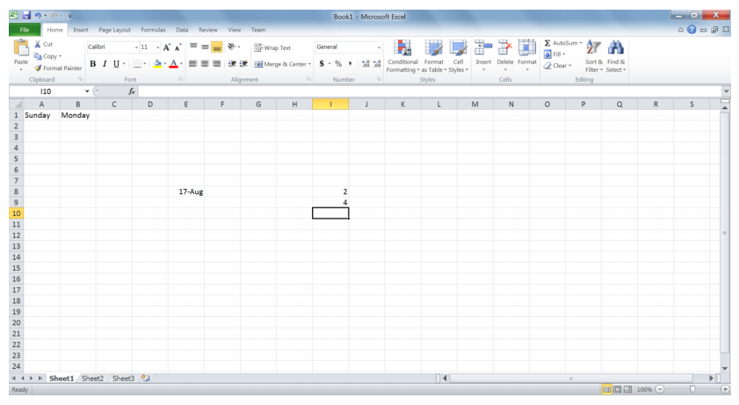

Notice how Excel automatically detected that 17/08 was a date and converted it to 17-Aug. We will discuss formatting data later on in this lab.

Now, we want to select both cells A1 and B1 together. To do this, click A1 and without releasing themouse button, move the mouse over cell B1. Now there should be a rectangle around both cells asshown below.

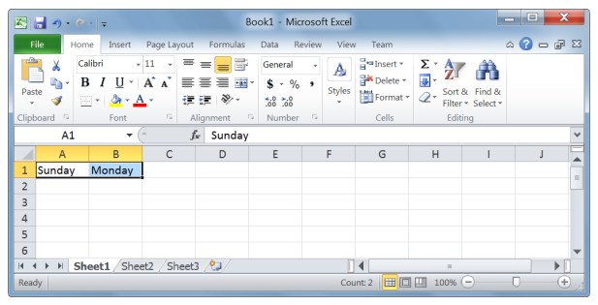

To get excel to auto-complete this row, we now position the mouse cursor at the bottom-left corner of the rectangle. Make sure the cursor has changed into a + sign. Now hold down the cursor and drag it to the left till I1.

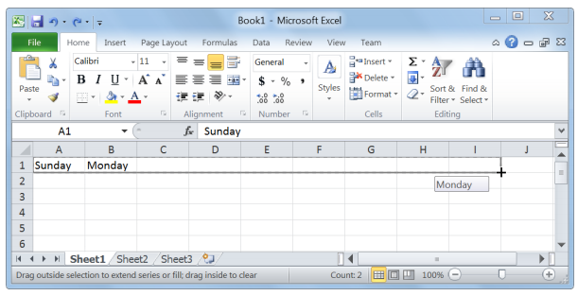

This is what your spreadsheet should look like when you release the mouse button:

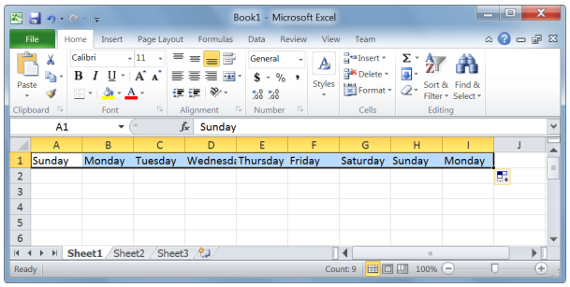

**Exercise 2**

* 1. Auto-complete cells I8 and I9 all the way to I14.
  2. Auto-complete cell E8 all the way to E12.

**Formatting**

Excel allows you to format your data so that it shows up in the way you need it to. Let us start with number formatting. Select cells I8 and I9. If you take a look at the Number group in the Home tab on the ribbon, you will notice that the current number format is “General”:

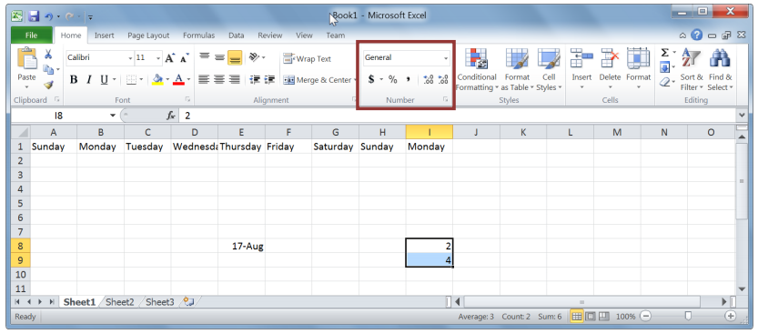

Selecting that drop down box shows you some of the available number formats, as shown below.

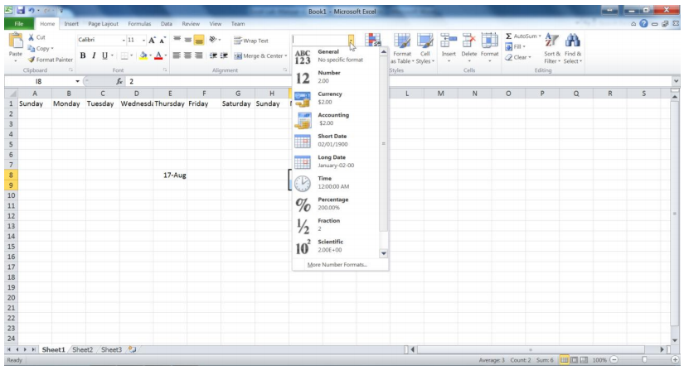

Select currency from the drop down menu. Now, you will notice that the two numbers have a $ signpreceding them, and have two decimal places. Let us change the currency symbol to a Euro. Select the Euro symbol from the currency format menu.

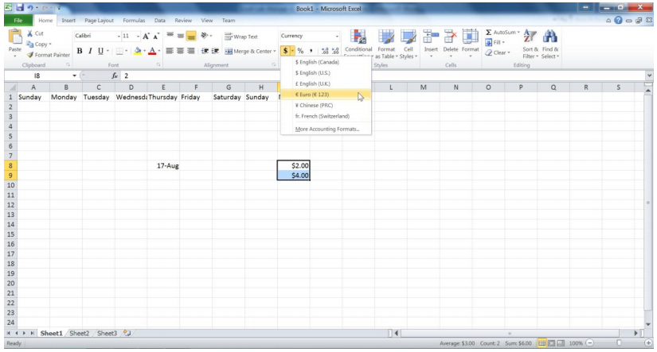

**Exercise 3**

Modify cells I8 and I9 by removing the 2 decimal places.

**Exercise 4**

Format cell E8 so that it looks like August 17, 2010.

**Basic calculations**

When working on a spreadsheet, you will almost definitely need to perform some calculations on thedata you have. The first thing you need to remember about Excel calculations is that formulas always start with an = sign. Let us begin with a very simple calculation. Type “=3+5” into cell A5 as shown below.

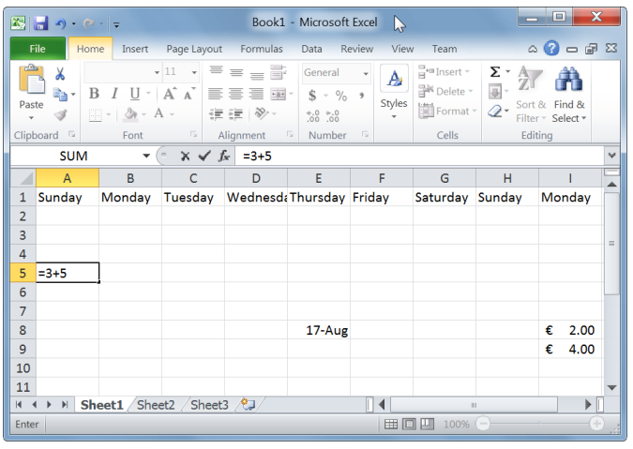

Press Enter. Excel automatically replaces the formula with the result of the equation.

Now let us calculate the sum of the numbers in I8 and I9. In cell J10, type “=I8+I9”. One other option is to type in “=”, then select cell I8. After that, type in “+” and then select I9.

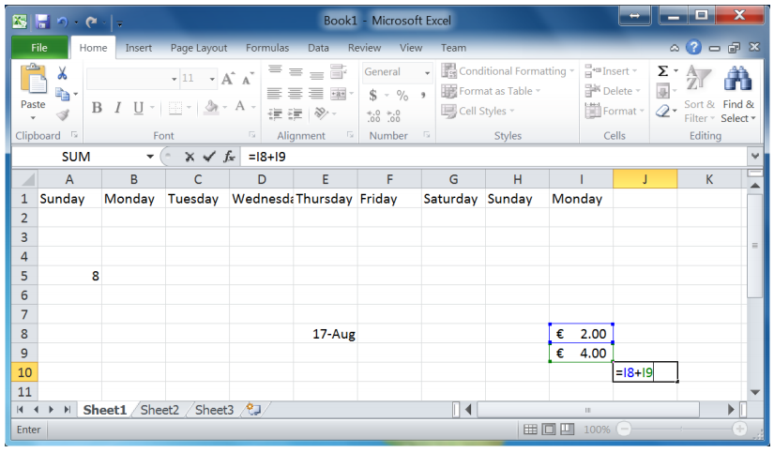

Pressing Enter will give you the result of the calculation. Double-clicking on the cell with the formula allows you to edit the formula.

Excel has built-in functions that make your life easier. One of them is the SUM function. In cell J11, type “=sum(“. Now select both cells I8 and I9.

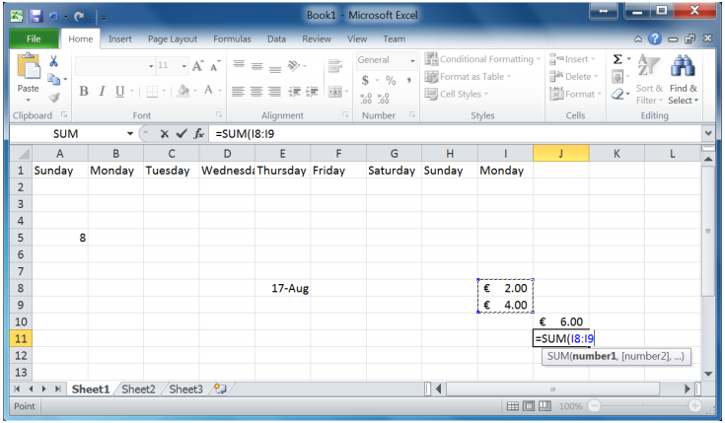

Pressing Enter gives you the same result as the plus operation we did in cell J10. Try changing the value in cell I8 and notice how the change is reflected in both formulas.

**Exercise 5**

1. Open Sheet 2 in your workbook.
2. In cells A1 and A2, type 1000 and 1500 respectively.
3. Use auto-complete to fill in cells A3 to A8.
4. Format the numbers so that they show the 1000 separator (1,000) and have one decimal place.
5. Calculate the following values for cells A1 to A8 using built-in Excel functions:
   1. Sum
   2. Maximum
   3. Minimum
   4. Average
   5. Median
   6. Standard deviation
6. Enter the number 5000 into cell A9 and modify all the above formulas to include it.
7. Calculate the sum of the Maximum and Minimum, and then divide this number by the standard deviation.

***LAB 10***

***Introduction to MS Office Excel (Charts and Pivot Tables)***

**Charts**

Turning data into charts can help visualize the information at hand. To convey the appropriate message from your data, you need to select an appropriate type of chart for your data.

Let us start out with creating a simple chart using the chart wizard. Open the file excellab2.xslx. In thetotal expenses sheet, you will see a table showing the total expenses accumulated by a company in the 12 months of a particular year. Select the entire table.

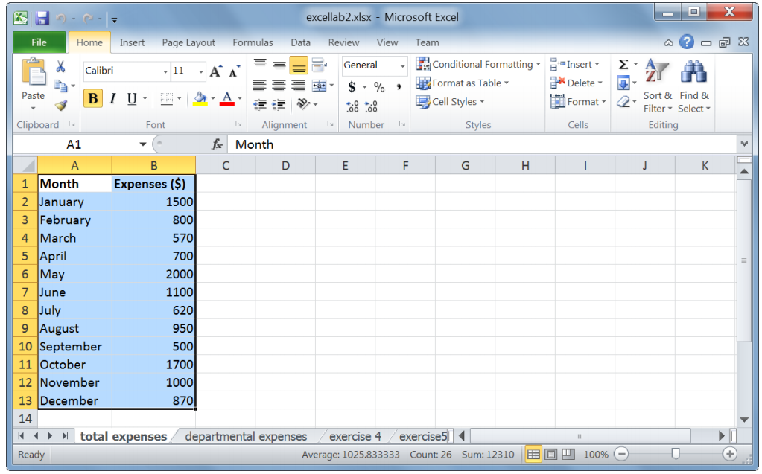

On the ribbon, click the Insert tab. There you will notice the Charts group, showing all the different types of charts that can be created out of the data. Select the 1stoption in 2D bars (the clustered bar chart).

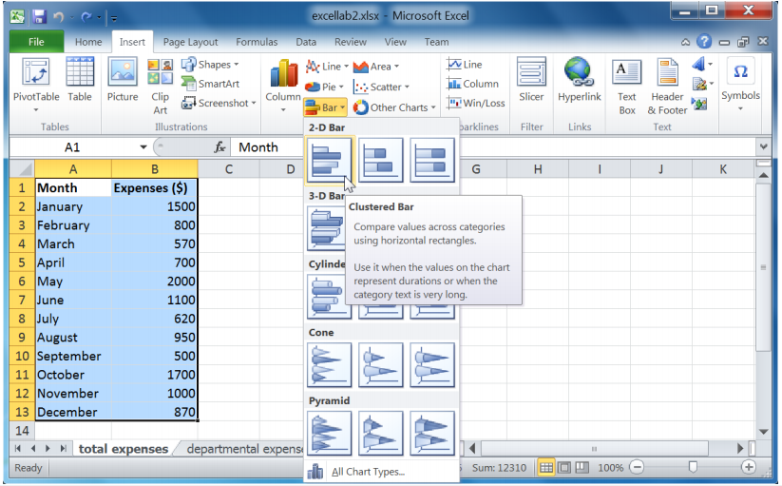

This is the chart Excel creates:

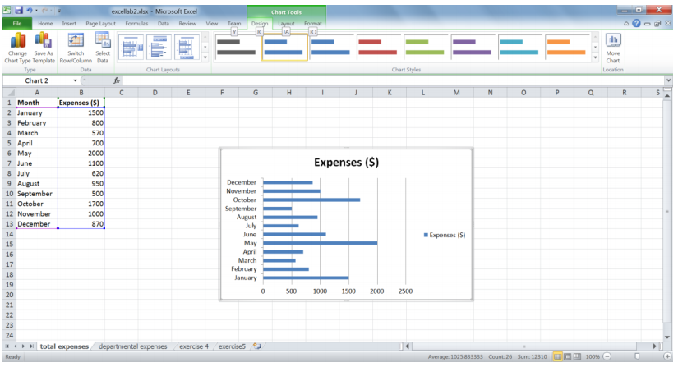

You may need to drag the corner of the chart to make it larger so that all the months are clearly visible on the y-axis. The chart needs some tweaking. First, we need to decide what extra information we want the chart to show. We want this chart to have a meaningful title and show a title for the x-axis. We do not need a legend, a title for the y-axis nor data labels. Now that I know what we want, the chart becomes very easy to customize using Excel’s chart layouts.

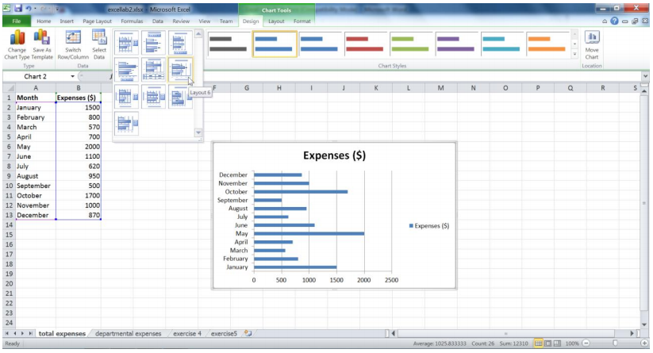

Looking at Excel’s built-in layouts, you will notice that none of them quite satisfy our chart requirements. Here we have two options. One option is to select one of the layouts and modify it to fit our needs. For instance, we could pick Layout 6 and simply delete the data labels. The other optionwould be to go to the Layout tab in the Chart Tools menu. This tab lets you fine tune the layout of the chart.

Take a look at the Labels group in the Layout tab. Since we already have a chart title, we do not need to worry about it. Let us add the x-axis title. Select Axis Titles, then hover over Primary Horizontal Axis Title, and select Title below Axis.

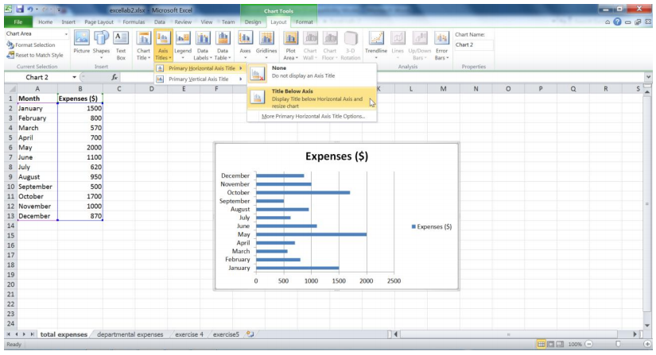

The chart now shows an x-axis title:

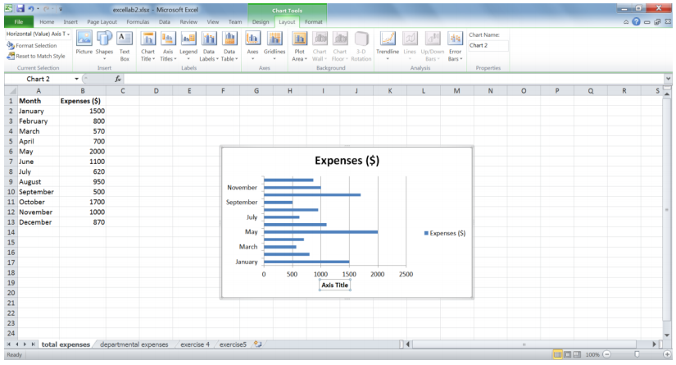

**Exercise 1**

Remove the legend through the Labels group in the Layout tab. If needed, adjust the chart size so that all the data are clearly visible.

Now that the layout of the chart is what we want, let us enter the correct titles. Click the chart title and replace it with “Total expenses for 2009”. Do the same for the axis title and replace it with “Expenses ($)”.

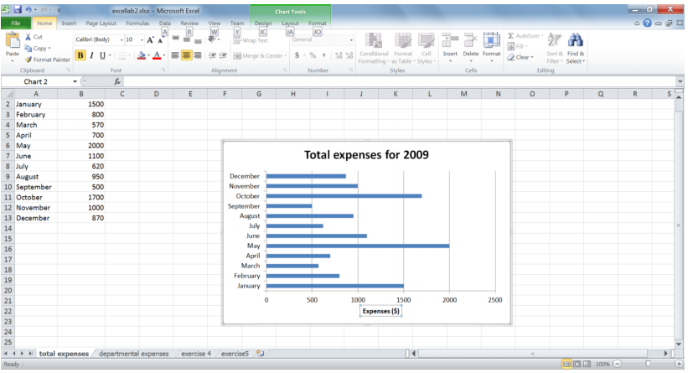

Now we can play around with the chart colors. Again, Excel allows you to either select one of its predefined themes or to change the background and colors, one at a time. Select Style 25 from the Chart Styles group in the Design tab.

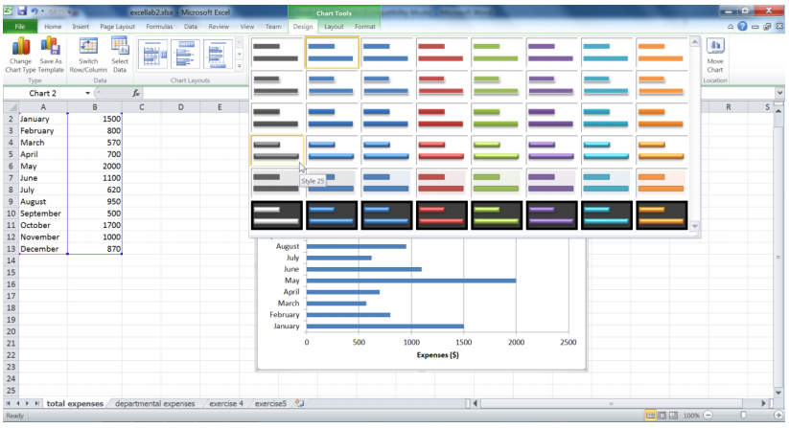

Your chart now looks like this:

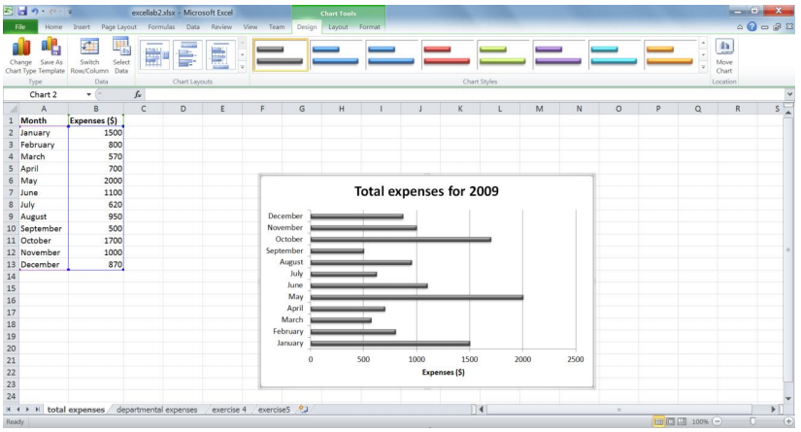

Let’s do a little more formatting. Select the chart area (the box that encompasses the chart title and plot area). Go to the Format tab and under Shape styles, select Subtle Effect - Purple, Accent 4.

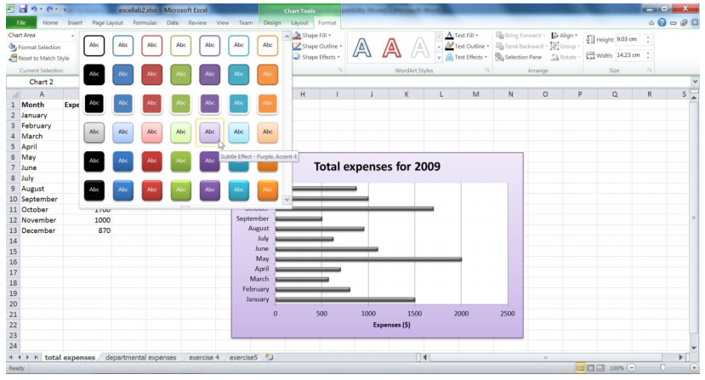

Now, select the plot area (the area that includes the chart ONLY) and select Colored Outline - Dark 1.

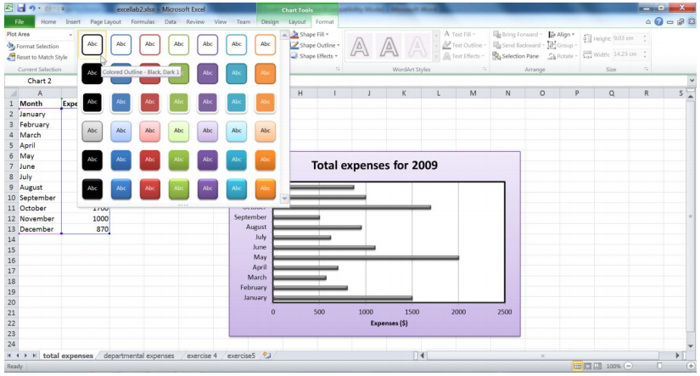

It is quite easy to change the chart type in Excel. To do this, select the chart area and go to the Insert tab. Select the Clustered Column from the Column charts menu.

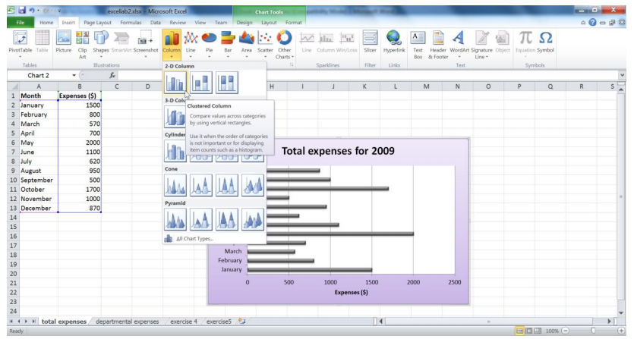

This changes the chart type as follows:

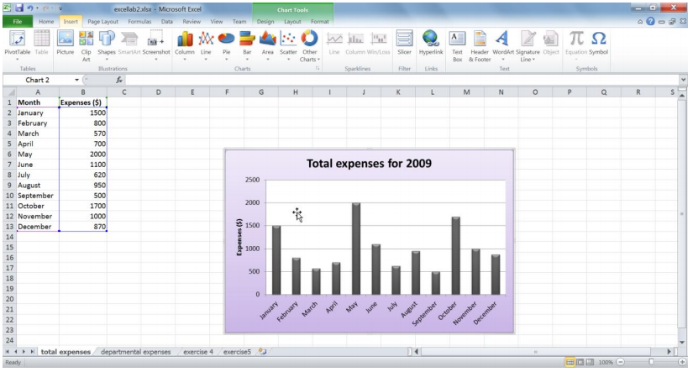

**Exercise 2**

Using the same table, create a 2D pie chart. Instead of showing absolute values, we would like the chart to show the percentages that each segment makes up as a data label. The month name should also be part of the label and the legend is not needed. The labels should be at the inside end of the data points.

Make sure the chart has a meaningful title. Adjust the chart size so that all the data is clearly visible.

Give the chart area a black border.

**Pivot tables**

Pivot tables are used to easily create meaning out of large amounts of data. Let us take an example. Open the departmental expenses sheet. Select the entire table and then go to the Insert tab on the ribbon. Click the PivotTable button.

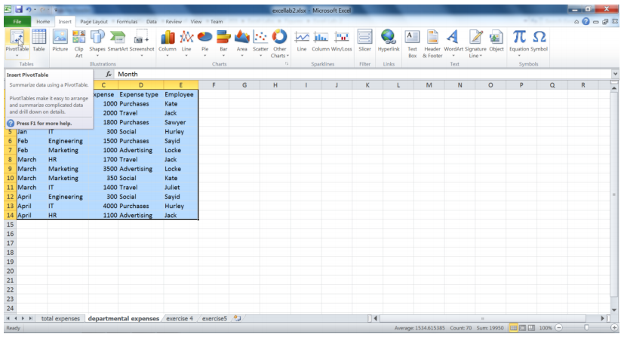

The dialog box that pops up allows you to modify the range of data to be used for the pivot table, and to choose where the pivot table needs to be placed. Leave everything as is and press the OK button.

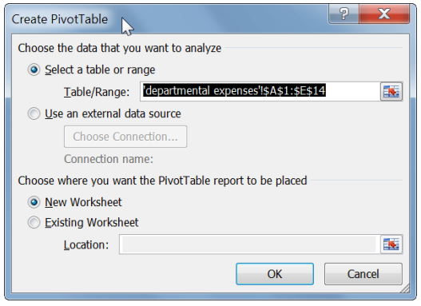

This is what you should get:

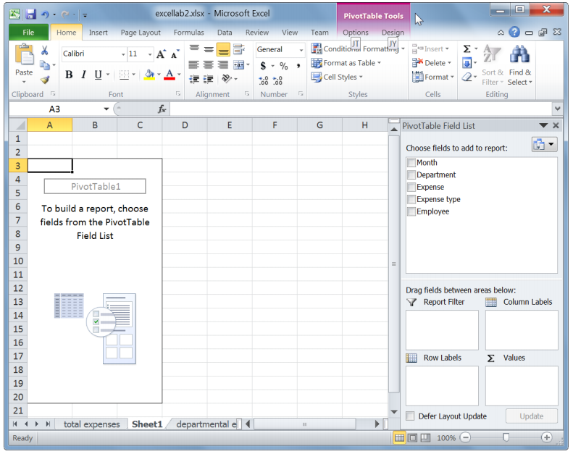

Let us first take a look at what the different field areas are used for. Their usage will become clear shortly.

* Values: this is used to display summary calculations in the pivot table.
* Row labels: these labels are used to display fields as rows on the side of the pivot table. The table is broken down by the first row label; each subsequent label appears as subcategory of the previous label.
* Column labels: these labels are used to display fields as columns on the top of the pivot table. Column labels are nested in a similar way to row labels.
* Report filter: this is used to filter the whole report (the pivot table).

The pivot table menu to the right allows you to select the fields you want to add to the table. Select all of the fields by clicking their respective checkboxes.

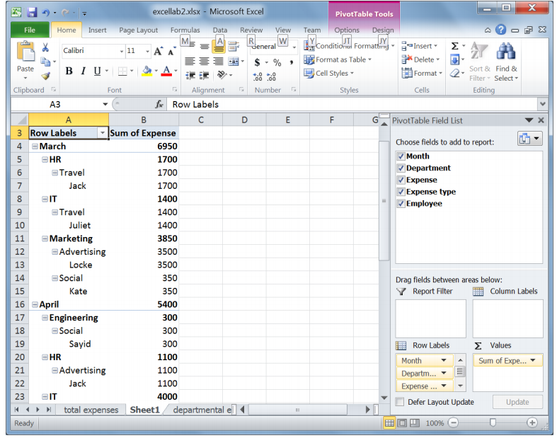

At this stage, the pivot table does not look like anything that makes sense. We need to tweak it a little bit to show the information we need. Notice that all the fields have come under Row Labels, except for Expense, which is under Values.

Drag the Expense Type field to Report Filter. Drag the Department field to the Column Labels.

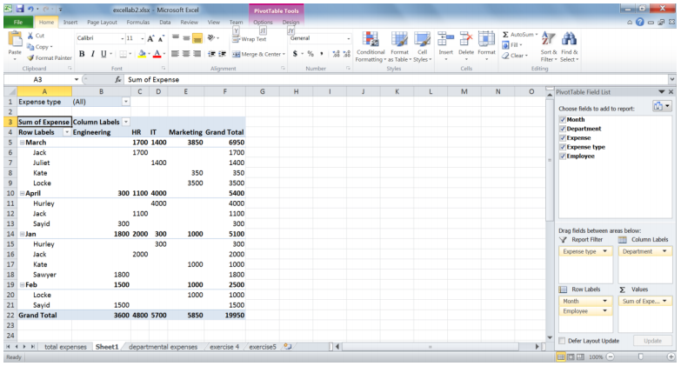

Notice how more meaningful the pivot table has become. It shows the total departmental expenditures per month, as well as each person’s expenditures in each month. To rearrange the months so that they are in the correct order, select the cell you want reordered and then move the mouse along the borders of the cell until a 4-headed arrow appears. You can then drag the cell to its new location.

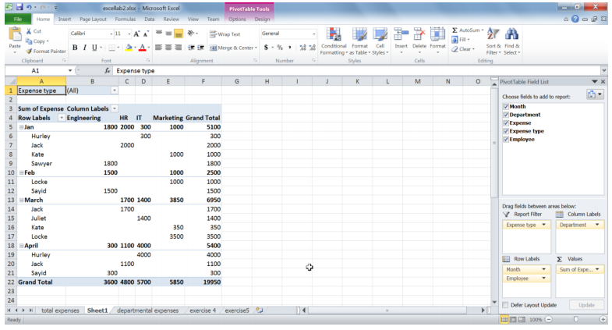

Now assume that we only want the information for Travel and Social expenses. Click on the drop-down field next to Expense type, and then check the Select Multiple Items checkbox. After that, deselect the Expense types we do not need and click OK.

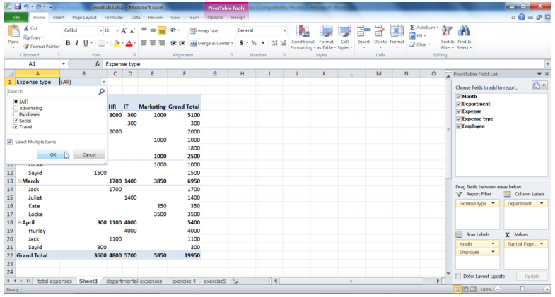

Now, the pivot table shows the information for only the required expense types.

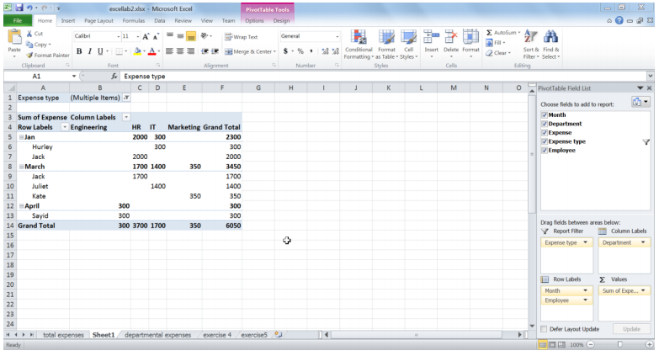

You can also filter column and row labels in the same way. Excel pivot tables allow for different calculations of the data value. Currently, the Expenses are being summed up. Let us modify this so that the table shows the average of all expenses.

In the pivot table field list (to the right of the screen), click on Sum of Expenses and select Value Field settings from the menu.

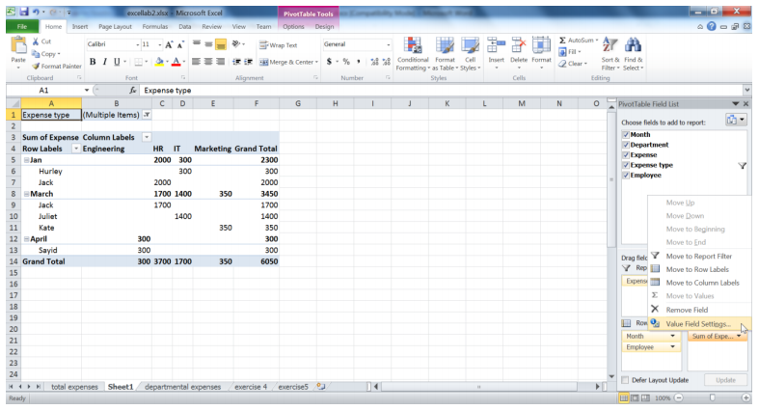

The dialog box allows you to select the calculation type for the data field. Select Average and then press the OK button.

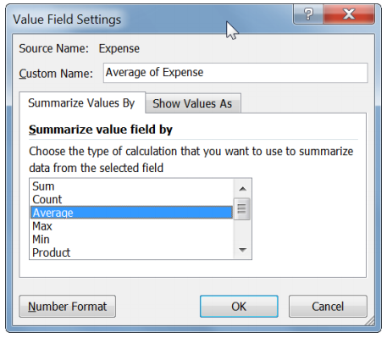

The pivot table now shows the average of expenses instead of the sum.

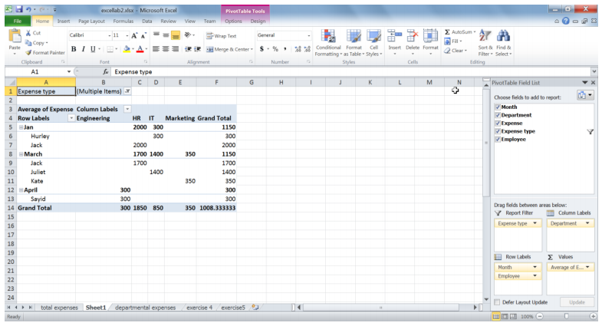

**Exercise 3**

Modify the pivot table so that it shows the number of times expenses incurred for each month, per department and per employee, for all expense types.

**Exercise 4**

Go to the exercise4 sheet in your workbook. The data in the table shows the population in Canada by age and sex group for 2009.

* 1. Calculate the totals for each column and row
  2. Make sure all your data shows the 1000 separator mark.
  3. Create a meaningful chart out of this table. Make sure you include titles and data labels as appropriate.
  4. Modify both the chart and plot area backgrounds to colors of your choice.

**Exercise 5**

Go to the exercise5 sheet in your workbook.

1. Format the dates so that they are in the dd/mm/yyyy format.
2. Format the expense amounts so that they show the $ sign (without decimal places).
3. Create a pivot table that shows the total amounts spent on groceries and clothes, by date and store.

***LAB 11***

***Introduction to MS Office Excel (Conditionals and Lookup Tables)***

**Conditional functions**

One very useful set of built-in functions in Excel is conditional functions. As the name implies, these perform certain operations based when a specified condition is satisfied. This is best illustrated through an example. Open excellab3.xslx and go to the sheet named conditions. Now, let us use Excel to give us a count of the number of employees in each department.

For this, we use the function COUNTIF. The form of this function is COUNTIF(Range, Criteria). The range is the data values you would like the count to be performed on, and the criteria are the conditions that need to be satisfied for a cell to be included in the count.

Let us count the number of employees in the IT department. Type =countif( and then select the range of cells we would like to count.

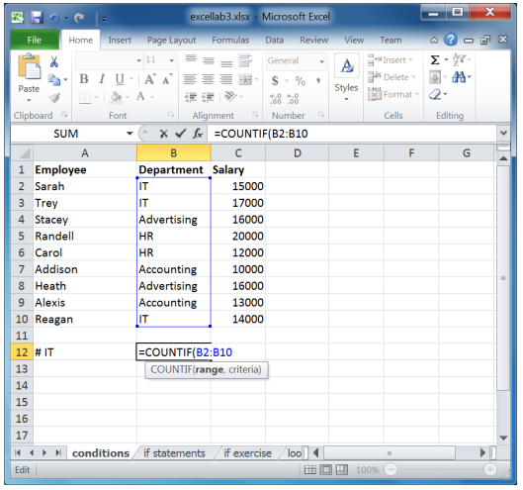

Now we need to enter the criteria.

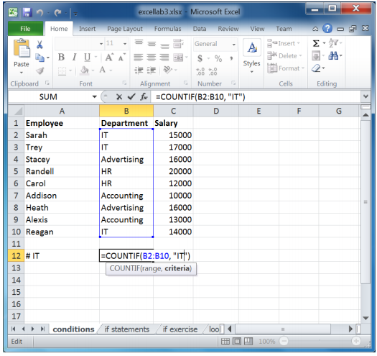

Note that IT was placed between quotation marks, as should any criteria you enter. When you press Enter, the result of the formula is shown.

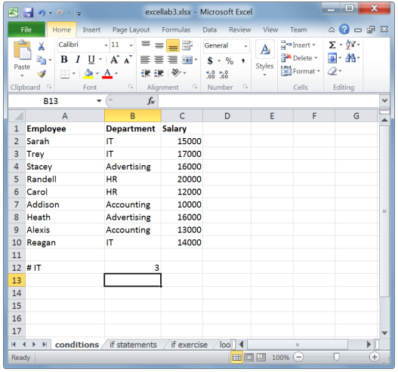

**Exercise 1**

* 1. Calculate the number of employees in the Accounting department.
  2. Calculate the number of employees with a salary greater than 15000 (remember the quotation marks around the entire criteria).

Now let us try using a cell address as a criterion. We would like to find the number of employees who have a salary greater than Reagan’s salary. The only difference here is that to include a cell address in the criterion; there is a special syntax as shown below.

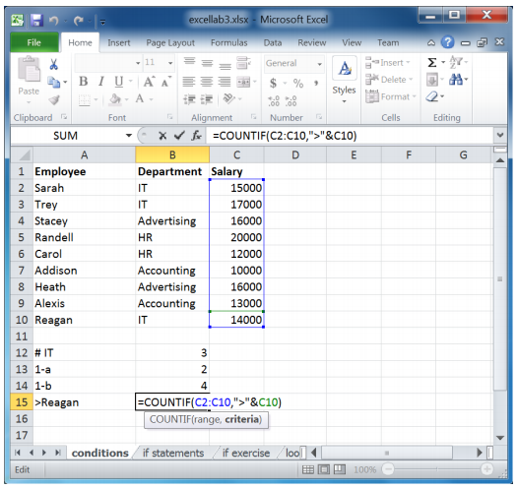

In other words, the operation symbol remains between quotations and then the cell address is appended to it using an ampersand (&).

**Exercise 2**

* 1. Calculate the number of employees who are NOT in the IT department. (hint: the not equal sign is <>)
  2. Calculate the number of employees with a salary greater than or equal to Alexis’, and less than Trey’s. Remember to use cell addresses. (Hint: use two countif operations.)

SUMIF works in almost the same way as COUNTIF, except it returns the sum instead of the count. For instance, let us calculate the sum of all salaries greater than 15000.

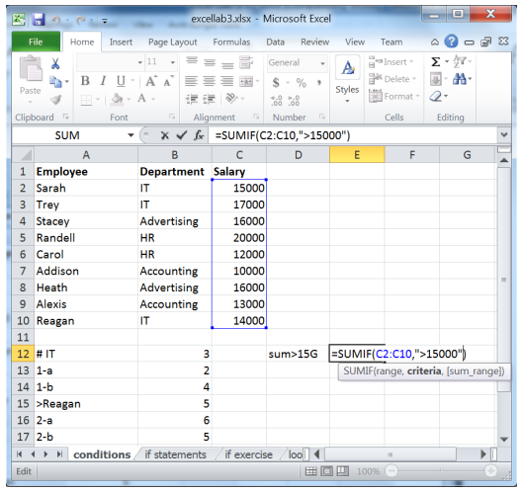

SUMIF also lets you define separate ranges for the criterion and the summation. For example, we might want to calculate the sum of all salaries of the IT department.

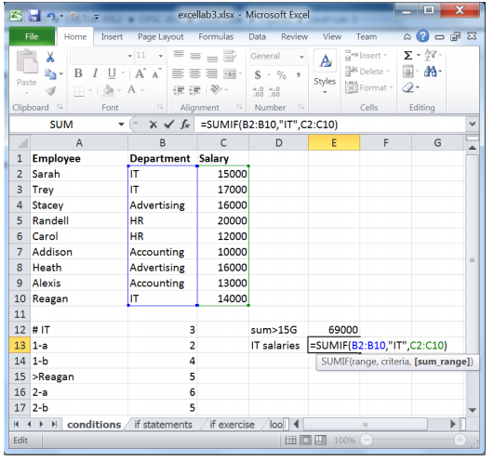

As you can see above, we first provide the formula with the range of values on which the criteria will be applied. We then enter the criteria, followed by the range which is to be summed up if the criteria apply to the 1strange.

**Exercise 3**

* 1. Calculate the sum of all salaries that are below the average of salaries.
  2. Calculate the sum of salaries of the HR and Accounting departments.
  3. Using AVERAGEIF, calculate the average of all salaries that are less than or equal to Stacey’s.

**IF functions**

IF functions or statements allow you to ask the question “is this true or false?” It then allows you to implement different actions based on the outcome. That is, it allows you to compute two different outcomes based on whether a certain criterion (logical test) is true or false. The format of an IFstatement is as follows:

=IF(logical test, value if true, value if false).

In excellab3.xslx, open the if statements sheet. The grades shown are for a pass/fail course, with the passing grade starting at 60. Let us use IF statements to display which students have passed, and which have failed.

First, start with the logical condition that needs to be evaluated. In this case, a student passes the course if her/his grade is greater than or equal to 60, say. The symbol >= means greater or equal.

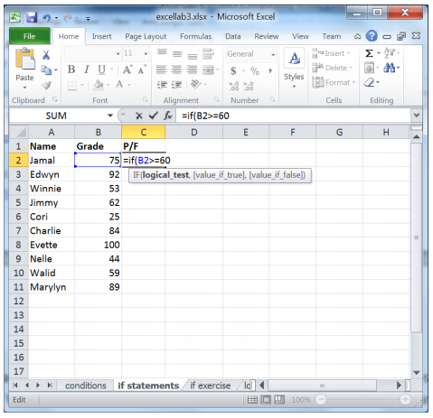

After we formulate the logical test (the student’s grade is >= 60), enter what we want Excel to display if this condition was true. In this case, we want Excel to display “Passed”.

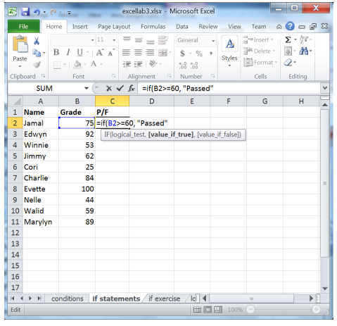

Finally, enter the value if the condition is false. The IF function shown below reads: if B2 is greater or equal to 60, then display passed; otherwise, display Failed.

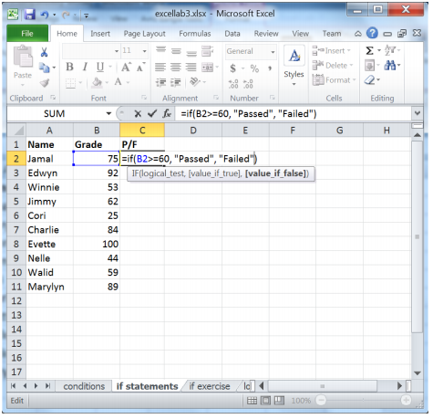

Now, drag the cell with the formula into the rest of the column.

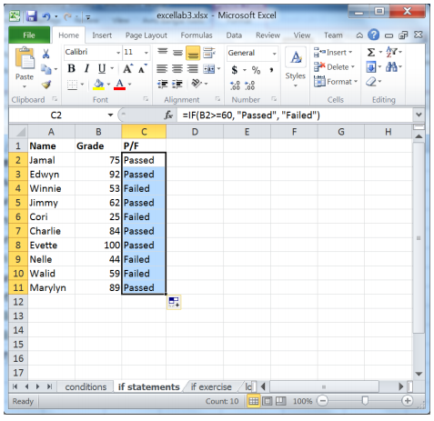

**Exercise 4**

The instructor for this course would like to reward the students who got a grade strictly above 85. Use if statements to display “Reward” or “No Reward” beside each student.

Now what happens if this course was not a pass/fail course, rather one with a letter grading scheme?

This requires the use of nested IF statements. Nested if statements allow you to embed IF statements in other IF statements, capturing more complex scenarios. Assume that following is our grading scheme:

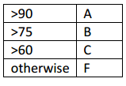

Nested IF statements are done by replacing the value if false or the value if true in the function with a new IF statement.

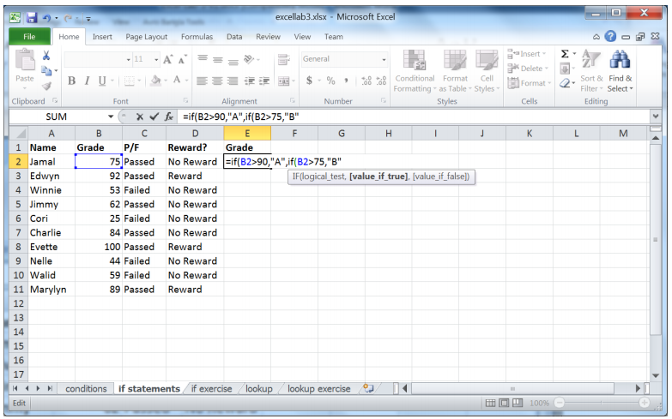

Notice that the logical condition of the IF function is similar to what we had done before: we require the grade cell to be greater than a certain value. Specifically, if B2>90, the Excel displays the letter mark A. If this condition is false, or B2 is less than or equal to 90, we need another IF condition in order to determine the letter grade since values that are less than or equal to 90 can result in different letter marks. For example, 77 is a B, 65 is a C, and 20 is F. All these values are less than or equal to 90.

Let us complete the entire function:

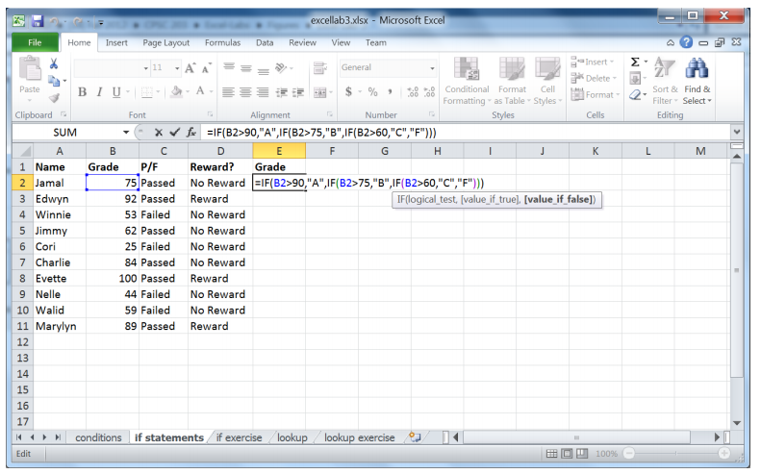

Notice that with each new IF statement, we opened up new parenthesis and that at the end we had toclose all of them. Drag the IF statement into the rest of the column.

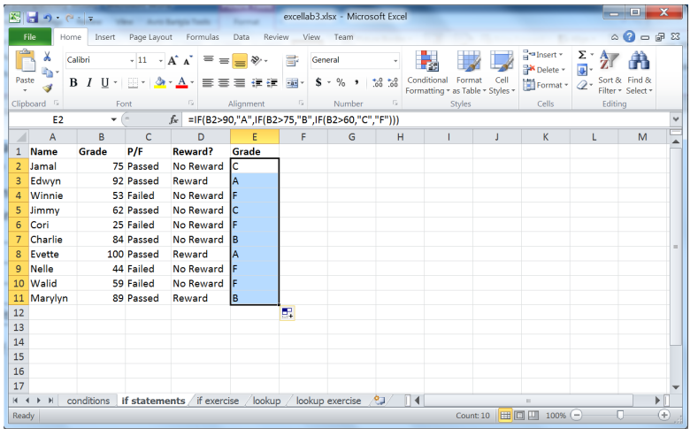

The following flowchart depicts how this IF function works.

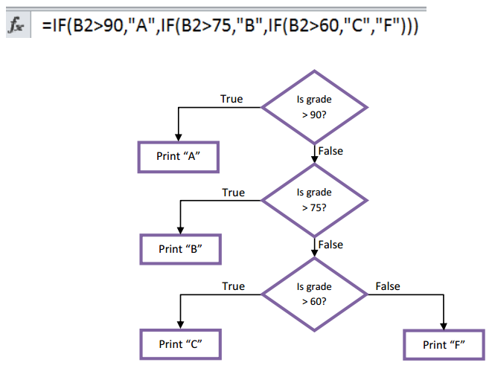

If B2>90, the A is displayed. If this logical condition is false (B2 is less than or equal to 90), a new if function takes effect: IF (B2>75,”B”,IF(B2>60,”C”,”F”)). In this function, the logical test is B2>75, the value if true is B, and the value if false is another if function: IF (B2>60,”C”,”F”). Hence, if B2>75 is true, B is displayed. If not, we need to check the mark if it is a C or an F. If B2>75 is false the last if function takes effect: IF (B2>60,”C”,”F”). If B2>60, display 60; otherwise, display F.

**Exercise 5**

Open the if exercise sheet. The sheet show the names of salespeople along with the revenues they have brought to the company. Using if functions, calculate their bonuses based on the following scheme:

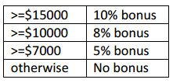

**Lookup functions**

You may have noticed that some of these if statements can get quite long. An easier way to match up the grades to their corresponding letter grade is to use the LOOKUP function.

The first thing you need to do is to create a lookup table that displays which numerical grades correspond to which letter grades. This is the grade distribution:

A >=90

B >=80

C >=65

D >=50

F otherwise

Open the lookup sheet.

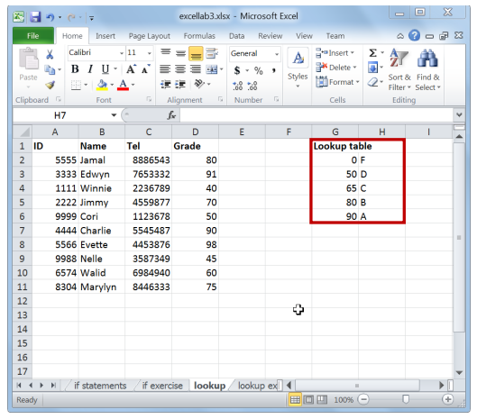

Notice that the lookup table is in ascending order (by the first column). It must be in ascending order for LOOKUP to work. The way this table is interpreted is that we are providing Excel with the minimum numerical grade for each letter grade. For instance, the F grade is between 0 and 50 (since a D starts at 50), not including 50. The A grade is anything greater than or equal to 90. If we had not set the minimum numerical grade for F as 0, any value below 50 would return an error.

Now let us put this table into action, using a LOOKUP function.

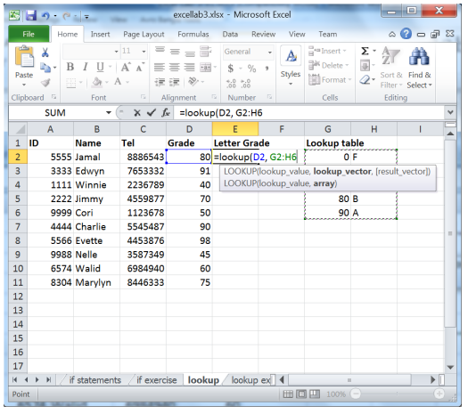

The first parameter we give the lookup function is the value to be looked up, which in this case, the numerical grade. The second input is the lookup table. Now drag the function to the rest of the column.

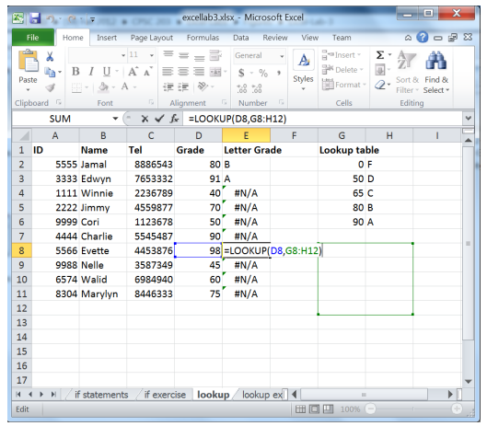

As you can see, we received plenty of error values. Double-clicking one of those values will show you the problem. When we dragged the formula, the address of the lookup table was incremented. Therefore, we need to fix the lookup table address in the formula. The way this is done is by adding $ as prefixes in cell addresses. The $ sign before a column name or a row number signifies an “absolute” or fixed address. When the formula is copied, Excel does not change absolute addresses. To the contrary, the reference D2 is called a “relative” address. In essence, it is saying lookup the value immediately to the left of cell E2 (where the lookup function is created) and go from there. So, when the formula is copied from E2 to E3, D2 will be updated to D3. Lookup tables should be always referenced in an absolute way.

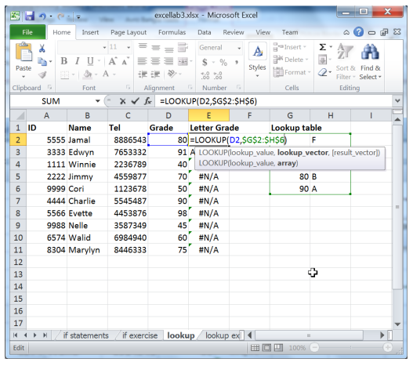

A shortcut to do this is by clicking on F4 right after selecting the lookup table. Now try dragging the formula again.

32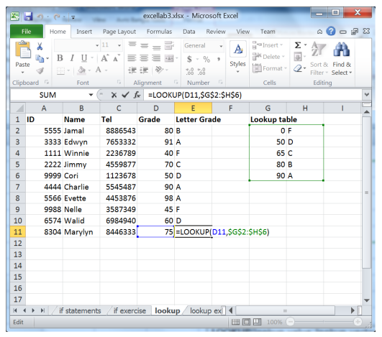

Now it all looks good, and as you can see above, the address of the lookup table was fixed.

Remember:

- The lookup table must be in ascending order.

- If lookup cannot find the exact match to the value you provided, it will return the result corresponding to the largest value that is less than or equal to the value you provided.

- If the value you are looking for is smaller than the smallest value in the table, an error value will bereturned.

**Exercise 6**

The following table provides the color frequencies in the visible spectrum

(<http://en.wikipedia.org/wiki/Visible_spectrum>).

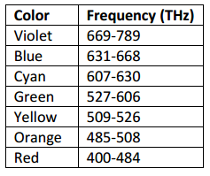

In the lookup exercise sheet, fill in the colors corresponding to the given frequencies using the lookup function.

***LAB 12***

***Introduction to MS Office Excel (Conditional Formatting and Lists)***

**Conditional formatting**

Conditional formatting allows you to make data trends stand out visually.

Open the file excellab4.xslx and navigate to the condForm sheet. Let us say we would like to quickly view who has OT (Over Time hours) more than 10 hours.

First, start by selecting your data range:

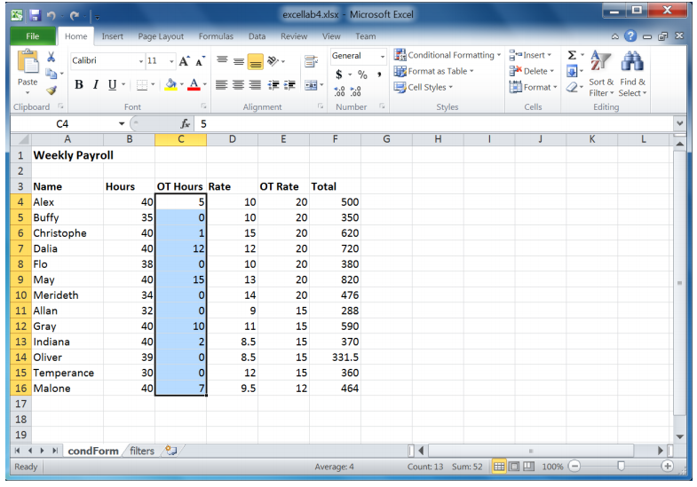

In the Home tab, click on Conditional Formatting in the Styles group. Move the mouse pointer over Highlight Cells Rules, and then click Greater Than.

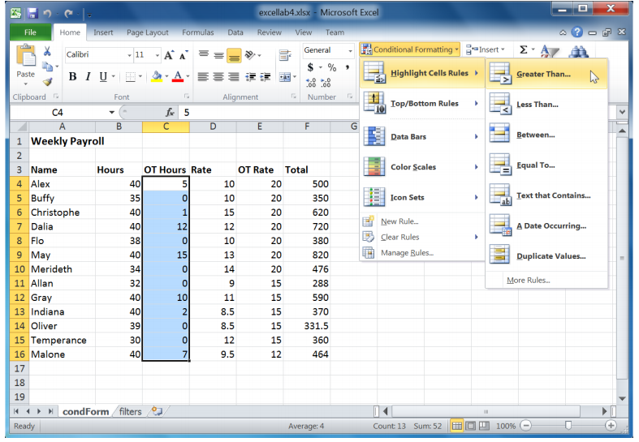

In the dialog box that pops up, Enter 10. Notice that you can modify the way that the cells are formattedby choosing the fill and text colors from the drop down list labeled with. For this exercise, leave the formatting as light red for the fill and dark red for the text. Click the OK button when you are done.

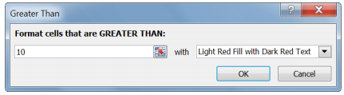

Now, OT hours that are greater than 10 have been highlighted.

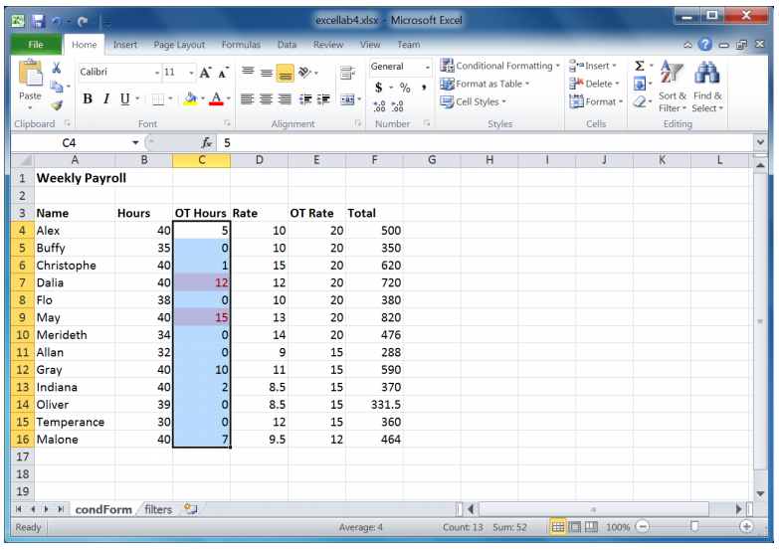

**Exercise 1**

Highlight the Hours that are in the bottom 20%. Format them so that they have a Yellow Fill with Dark Yellow Text. (Hint: use Top/Bottom Rules).

Other conditional formatting features allow you to get a quick overview of the values of all cells in a range. One of them is data bars. Data bars assign the longest bar to the largest value in a list and the shortest bar to the smallest value. The values in between are then given bars according to their respective values. Let us apply this to the Total column.

Select the range of cells under the Total heading. Click on the Conditional Formatting button and navigate to the Data Bars menu. Select the Purple Data Bar button.

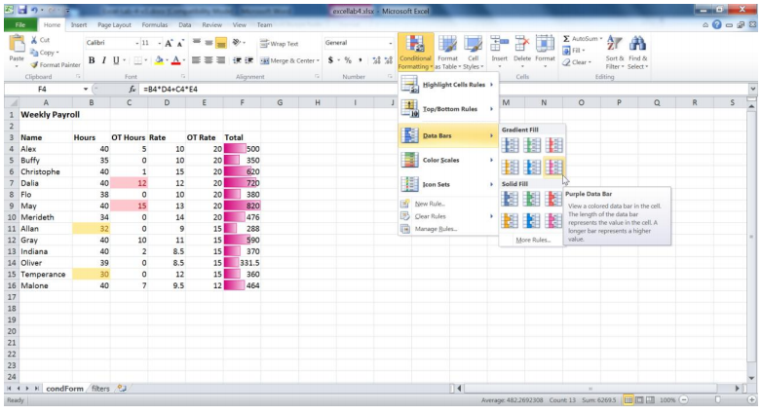

The data bars now provide you with a quick relative view of the total amounts employees earn.

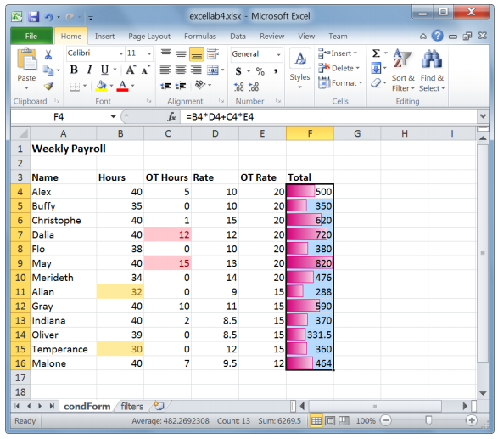

Using color scales also gives you a similar result as data bars. Both features allow you to get a quick view of how your data values compare to one another. The 2-color scales assign one color to the maximum value and another to the minimum. The values in between get assigned “in-between” colors. In addition, the 3-color scales assign a color to a selected midpoint. The colors and values assigned to them can be modified by selecting Manage Rules under the Conditional Formatting header.

You can also delete rules by selecting the cells where you would like to clear the rules, then navigating to the Clear Rules menu under Conditional Formatting. Click on Clear Rules from Selected Cells.

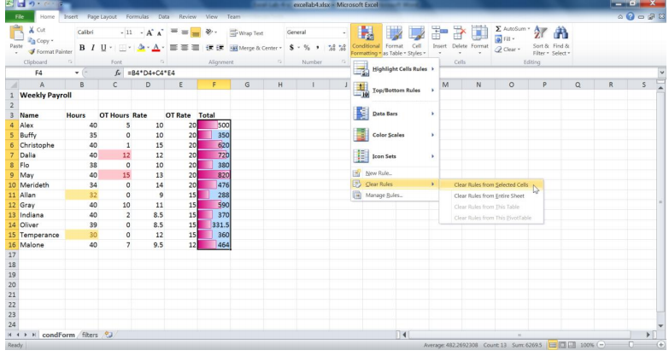

**Exercise 2**

After you have cleared the data bars rule from the Total column, apply the Green-Yellow-Red color scale.

**Exercise 3**

Edit this rule so that the maximum value is shown in a pretty sky blue color.

The final aspect of conditional formatting we will cover is icon sets. When using icon sets, each cell is provided with an icon depending on its value. There are no gradients in icon sets.

Let us format the Rate column using icon sets. Select the cells in the Rate column and apply the 3 traffic lights (rimmed) formatting to them, as shown below.

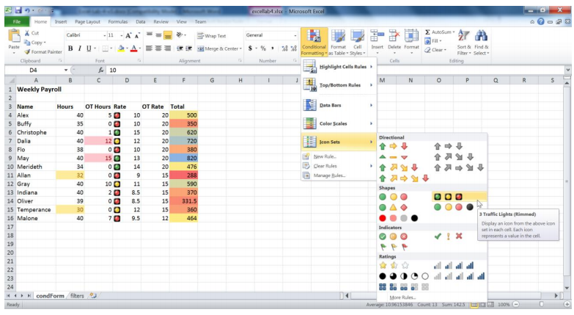

As you can see below, Excel assigns the icons based on its own calculations.

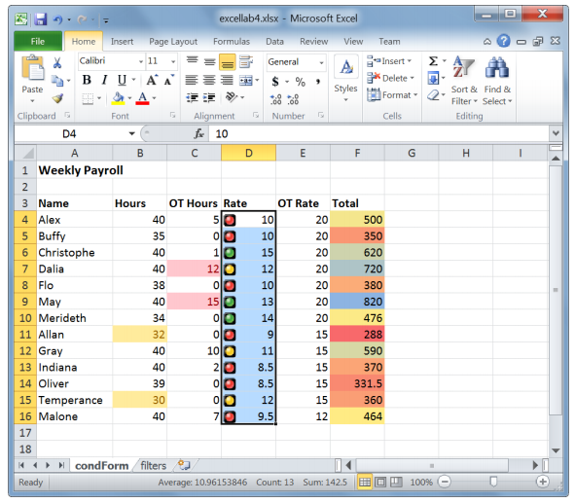

If you want to change the way that the icons are assigned, you need to edit the rule (Manage Rules). As you can see below, Excel is currently assigning the Green icon to values >= the 67 percent. What this means is that Green icons will be assigned to values >= 67 percent between the lowest value (8.5) and the highest (15). In this case, the minimum value associated with 67 percent is 0.67*(15-8.5)+8.5. This is 12.9. In other words, Excel calculates these percentages by assigning 100% to the highest value in the range and 0% to the lowest.

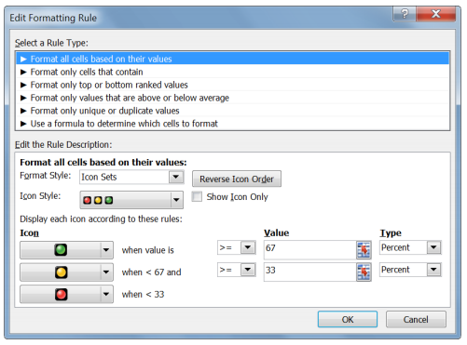

Let us change the type of values to Percentile instead of Percent.

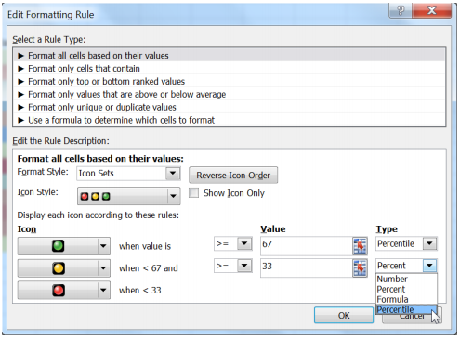

Notice the changes in the distribution of icons.

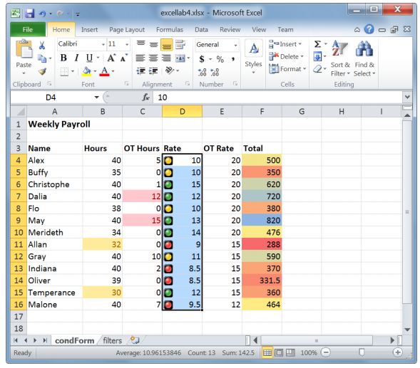

Percentiles do not calculate the percentages within ranges of values. Percentiles are based on the order of a value among the other values. Values <= the 33 percentile means that red icons will be assigned to the bottom 4 values. If you are interested in the Math, this is because 0.33*13 (the number of values) =4.29.

What you need to understand about this is that percentages are calculated relative to the lowest and highest values when percentiles are calculated based on the position of a value in the ordered list of values.

**Exercise 4**

Format the OT Rate column using the 3 flags icon style. The cells should show a RED flag if its value is >=20, a YELLOW flag if its value is <20 and >=15, and GREEN otherwise.

**Sorting lists**

Sorting a list or sorting an entire table are both functions that will most likely come up whenever you are doing data analysis. You can easily sort data in alphabetic, numeric, or even chronological order.

Let us try sorting our table by the ascending alphabetic order of the names of the employees. Select the range of names in the table. Then in the Home tab, under the Editing group, select Sort A to Z.

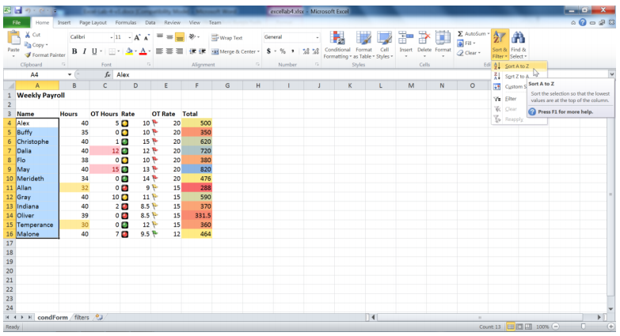

A warning message pops up:

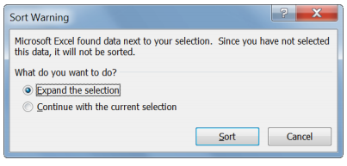

What this message is telling us is that with the current selection, only the names column will be sorted.

The data in the rest of the table will not be sorted. This is why we need to select the “Expand the selection” radio button. This will allow the entire table to be sorted according the alphabetic order of the names. Press the Sort button. The entire table has now been sorted.

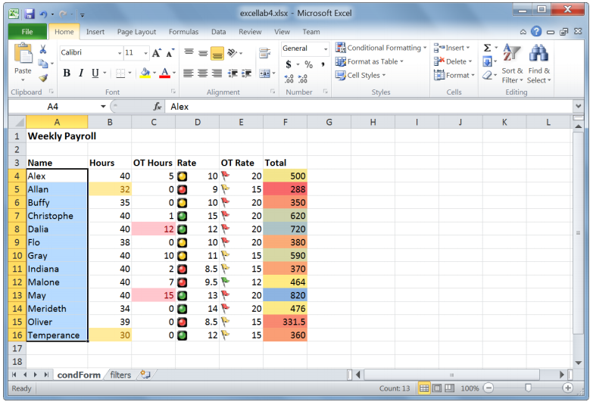

**Exercise 5**

Sort the table through the Hours column, from largest to smallest.

Excel also lets us perform more complicated sorting. Let us try to sort the table by the cell icons of the Rate column.

Select the entire table. Under Sort and Filter, select Custom Sort.

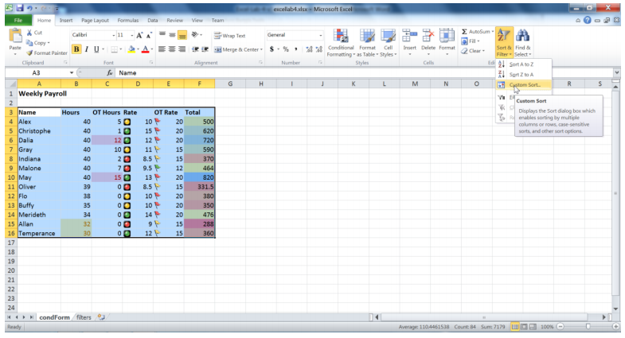

The custom sort dialog box pops up.

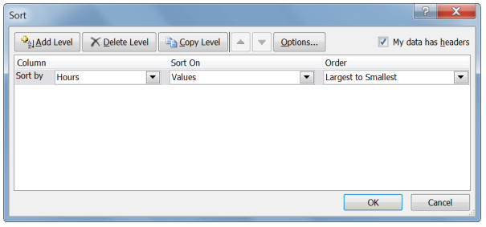

This dialog box shows the column headers in our table, how we want to sort them, and what order we want them in.

Select Rate as the Sort by column, and then select for it to be sorted on Cell Icon. The order menu now shows the three icons used in the Rate column. Let us ask for the green icon to be placed on top, as shown below.

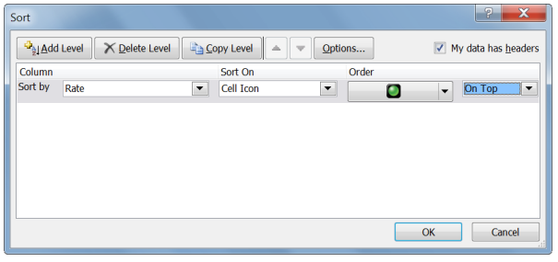

Now we can add another level of sorting so that the red icon is at the bottom. Click on the Add Level button in the dialog box. Select Rate and Cell Icon again. This time, make sure the red icon is ordered on the bottom, and then click the OK button.

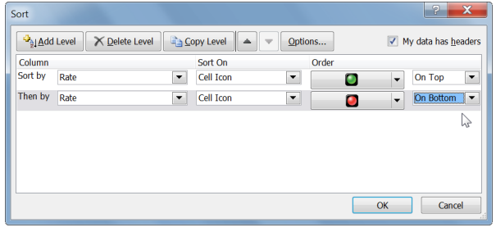

This is what your table should look like:

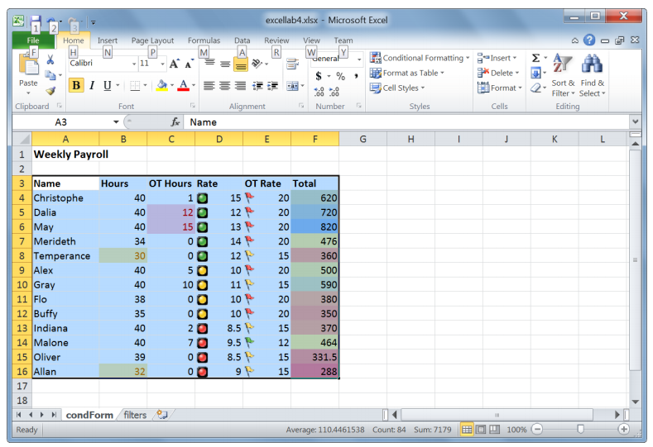

**Exercise 6**

Use custom sort to sort the table in the descending order of the OT Rate and then in ascending order of the names of the employees.

**Filtering lists**

Filtering in Excel allows you to show only the rows of data you are concerned with, and hide all other data temporarily.

Open the filters sheet in excellab4.xslx.

One obvious use for filters here is to view the sales information of only a few regions of interest. Let us see how this can be done.

Start by selecting the Region column. Under the Home tab and in the Editing Group, select the Sort and Filter button. Select Filter from the menu.

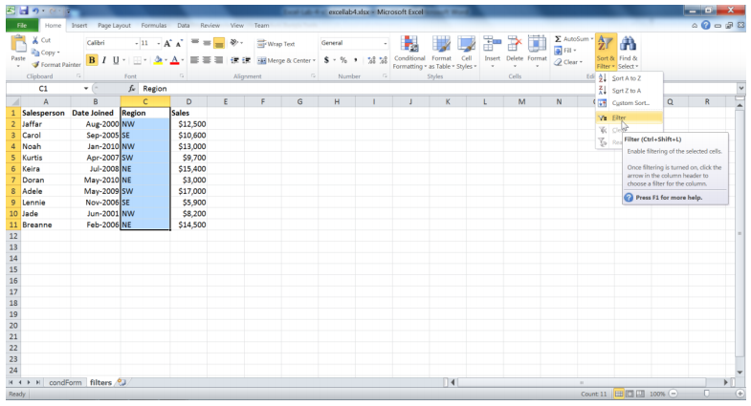

Notice that there is now an arrow next to the Region header. This arrow means that a filter can be applied to this column, but no filters are currently being used.

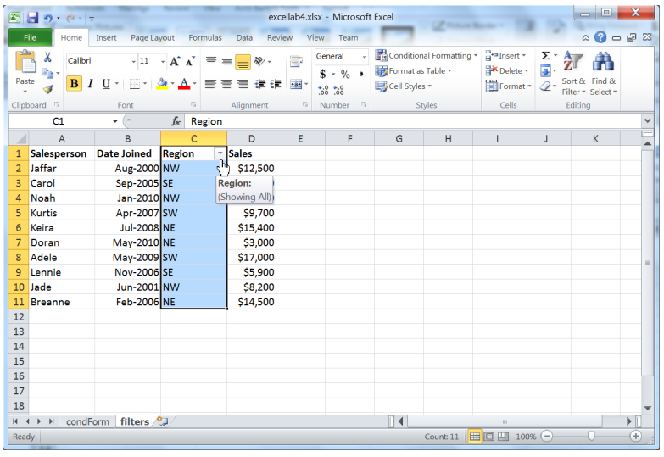

Click the arrow next to the Region header. Let us only show the data for sales in the East region. One way to do this is to deselect NW and SW as shown below.

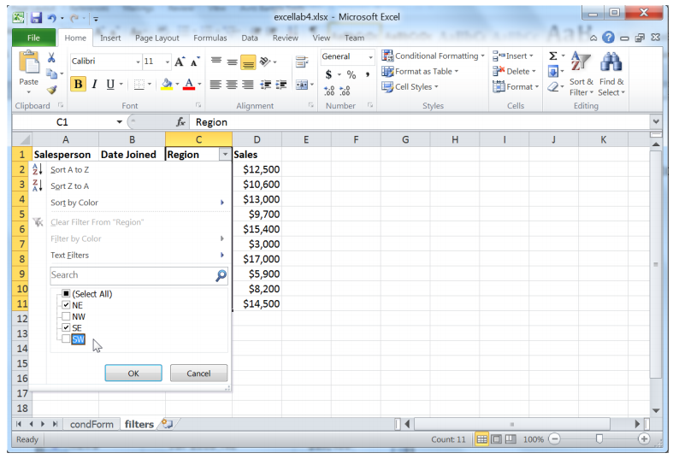

Now, only the rows showing information from either the NE or SE are shown. Notice the button next to the region header has changed to a filter icon indicating that a filter has been applied.

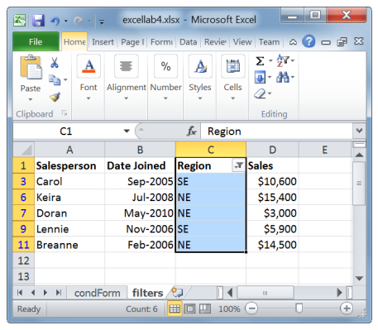

There is another way by which the same result can be achieved. First let us remove the applied filter.

Click on the button next to Region and select “Select All”. Click the OK button.

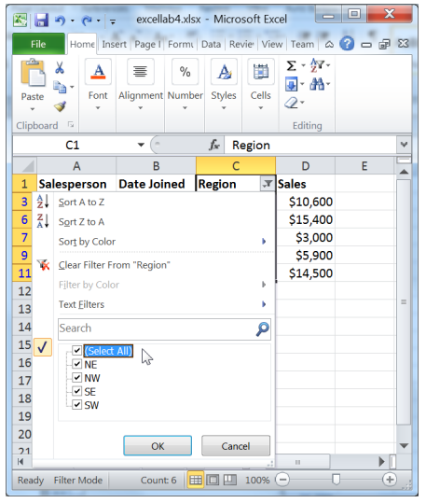

Now that we can see our original data, let us add a new filter. Select the arrow next to Region and move the mouse cursor over Text Filters. Choose Ends With.

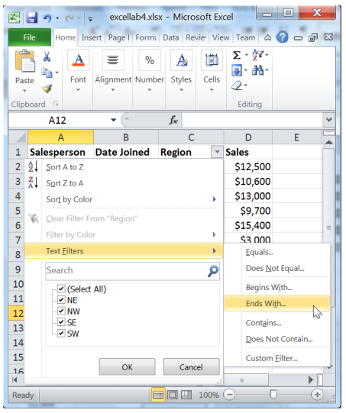

In the dialog box that pops up, enter E as shown below. This will only show the rows in which the Region ends with an E. Click on the OK button.

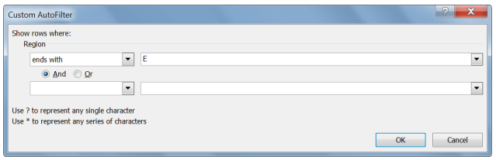

Now let us remove the filter by clicking on the button next to Region and selecting Clear Filter from “Region” from the menu.

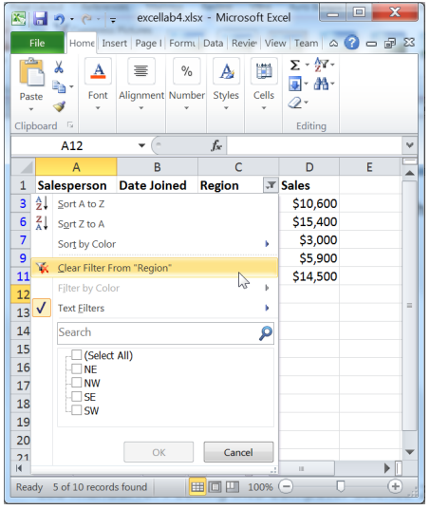

**Exercise 7**

Create a new filter that only shows the data for salespeople who have joined after May 2004, and before or during May 2008. Filter this further so that it only shows the ones who have sales less than $6000 or greater than $12000.

**Exercise 8**

Remove the previous filters from the table. Show only the rows from the months April, May, and June of all the years (2ndquarter). From those rows, only show the ones with Sales above the average.

***LAB 13***

***Introduction to MS Office Excel (Drop-Down Lists and Dynamic Charts)***

**Drop-down lists**

Drop-down lists are useful in making data entry easier and faster by limiting the number of options to pre-defined items.

Open the file excellab5.xslx and navigate to the dropdown sheet. The sheet shows a partial table of students in a class. We would like to limit the possible valid entries into the major column.

First, we need to create a list of all valid majors that will be accepted. Here are a few that one can think of. Feel free to add your own major if it is not in the list.

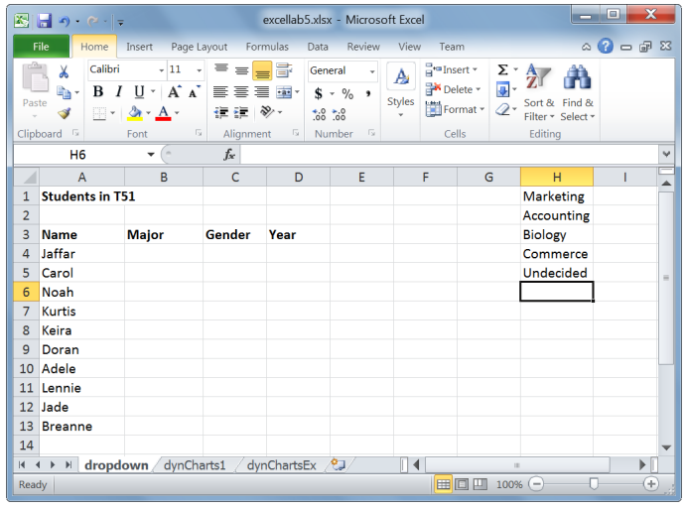

Next we need to name our list. Select the list of majors that was created. Go to the Name Box at the left of the formula bar (shown in a red square below) and type in an easy to remember, descriptive name of the list, such as ValidMajors.

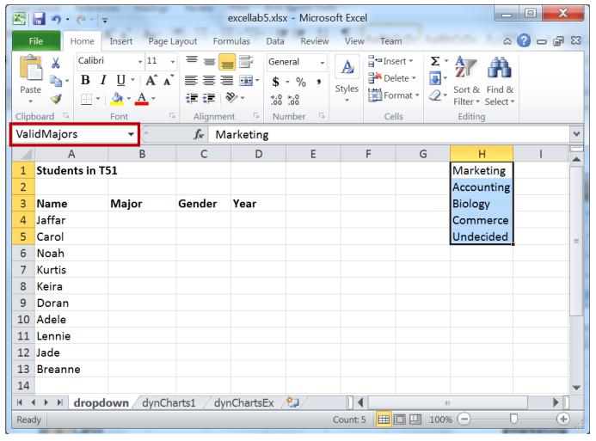

To create the drop-down list, first select the range in which the list will be used (see the illustration below). Then under the Data tab, select Data Validation from the Data Tools group.

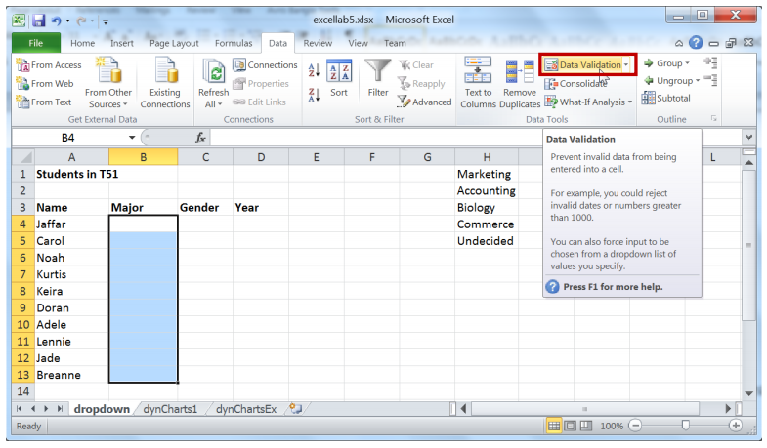

Go to the Settings tab in the dialog box that pops up. In the Allow box, select List. We need to pick the data source for our list. You can either enter = followed by the name of the list that was defined previously, or you can use the arrow to the right of the Source field to select your list manually.

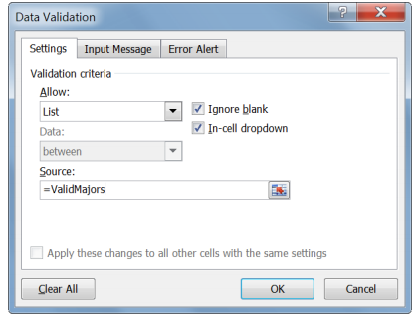

You can also ask Excel to show an input message describing to users what they need to do. Go to the Input Message tab and enter an appropriate title and input message:

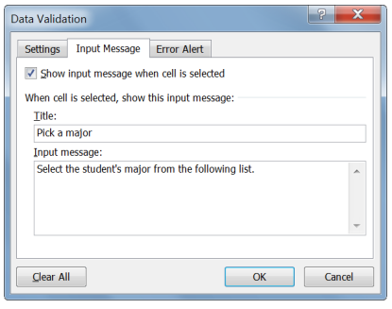

We can choose whether we want to restrict the user’s entries to the list, displaying an error message on any other entry. To do this, go to the Error Alert tab. Excel lets you pick the style of the error message, as well as the message title and body.

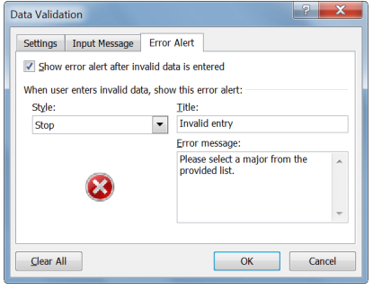

When you are done entering everything, press the OK button.

Now when you click on a cell in the Major column, you get an arrow indicating a drop-down list is available, as well as the input message we had provided. Try entering a major that is not on the list. You will see an error message.

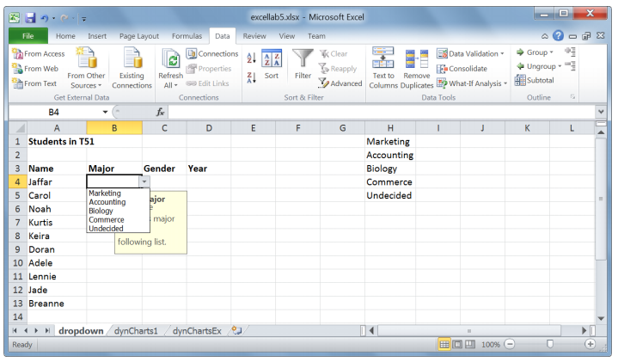

**Exercise 1**

Create a drop-down list for the Gender field. The list should show a warning message on invalid data entry. No input message is necessary.

**Exercise 2**

Create a drop-down list (freshman, sophomore, etc.) for the Year column with an error message. The list should not allow blank entries.

**OFFSET function**

The OFFSET function allows us to start somewhere in the spreadsheet, move in any direction in order to locate a cell or a range of adjacent cells, and return the value of this cell or a set of values for the range of cells. The general syntax for this function is:

OFFSET(reference, rows, cols, height, width)

Where:

* Reference: is the address of a cell or a range of adjacent cells
* Rows: is the number of rows to move from the reference. A positive number means moving down, and a negative number means moving up from the reference.
* Cols: is the number of columns to move from the reference. A positive number means moving right, and a negative number means moving left from the reference.
* Height: is an optional positive value indicating the number of data rows to be returned by the function.
* Width: is an optional positive value indicating the number of data columns to be returned by the function.

Let us understand how to use the OFFSET function through an example. Open the dynCharts1 sheet in excellab5.xlsx. In an empty cell, type =OFFSET(A2, 1, 1, 1, 1) and press Enter.

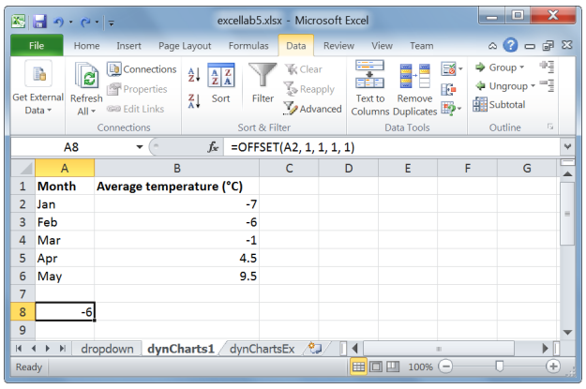

The value returned is -6 since the function reads as follows: move one row down (first 1) from cell A2 and one column right (second 1) of cell A2, and return a single cell. A height and width of 1 (third and fourth 1s, respectively) indicate it is a single cell that we are offsetting to. This is cell B3, which contains -6, the returned value. When both the height and width are 1s, these arguments can be simply left out.

For instance, OFFSET(A2, 1, 1, 1, 1) is equivalent to OFFSET(A2, 1, 1)

Try this one: =OFFSET(B5, -3, -1). Starting at cell B5, move 3 rows up and 1 column left. The size of the returned data is also one cell (since height and width are omitted). The offset is A2 and the value returned by this function is Jan.

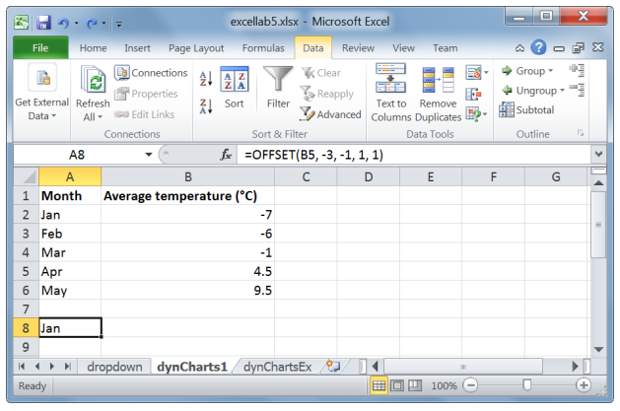

In order to specify a height or a width that is greater than 1, the OFFSET function must be used in another Excel function, such as SUM or AVERAGE. If you attempt to use it on its own, you will get an error message. For instance, if you type =SUM(OFFSET(A1, 1, 1, 5, 1)) in an empty cell, you will get an error message.

OFFSET(A1, 1, 1, 5, 1) refers to a range of adjacent cells, starting at A1, moving one row down and one column right this will take us to cell B2. B2 is the top left corner of the required range of values. The range of cells from B2 spans 5 rows and 1 column. Recall that height and width must always be positive.

Hence, OFFSET(A1, 1, 1, 5, 1) returns B2:B6 or all the average temperature values in the sheet.

Now, use OFFSET in a SUM function and type the formula: =SUM(OFFSET(A1, 1, 1, 5, 1)). Here we are adding all the temperature values together.

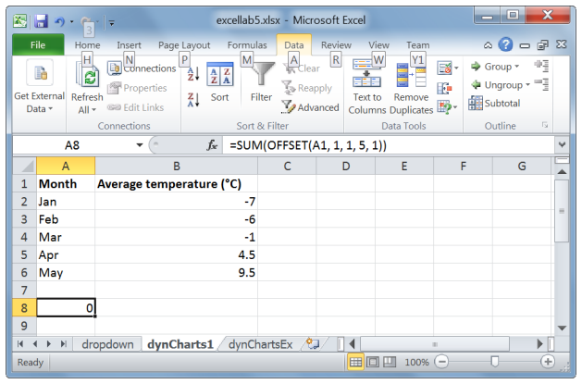

Now what if we want this SUM value to be updated whenever we add a new month’s value? Of course one way is modify the formula SUM(OFFSET(A1, 1, 1, 5, 1)) to include the newly added month. However, this is cumbersome. We would like this to be done automatically and without changing the formula that contains the OFFSET function. A combination of OFFSET and COUNTA can be very powerful.

COUNTA is a count function which counts all non-empty cells in a range. We can use it to count all nonempty values in Column B as such: COUNTA($B:$B). Our new formula is:

=SUM(OFFSET(A1,1,1,COUNTA($B:$B)-1,1))

The range of the OFFSET starts at A1, moving one row down and one column right. That is, the top left corner of the required range of cells is B2. B2 contains the first temperature value. The height of the range is COUNTA($B:$B) – 1, which is one less the number of non-empty cells in column B. Remember that the column title (Average Temperature (0C)) is a non-empty value, but it should not contribute to the number of values we are trying to sum up. Hence, COUNTA($B:$B) – 1 evaluates to 6 – 1, which is 5.

The returned value of the SUM function is 0, the 5 temperatures in column B cancel each other.

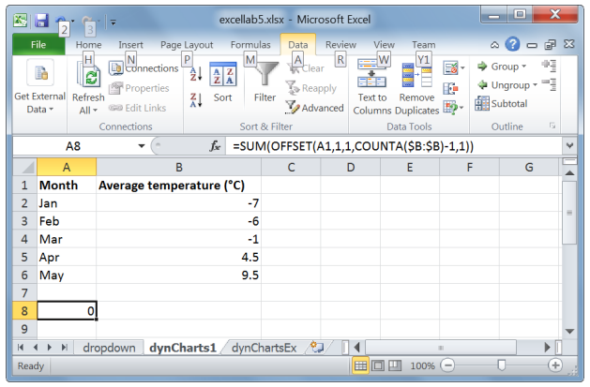

Now try adding a new value to our table: Jun and 13.5.

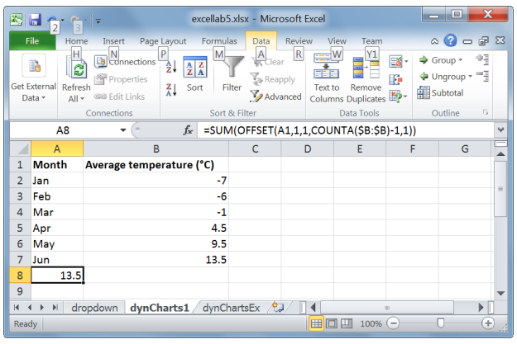

The SUM(OFFSET(A1,1,1,COUNTA($B:$B)-1,1)) function automatically includes the June value (13.5) in the sum since column B contains a new non-empty value now.

**Dynamic charts**

In this section, we will take a look at how to make a chart that dynamically updates its values. Data is dynamically added to charts by using the OFFSET function. Start by deleting the SUM formula that was created previously. Remember how we named a range of cells in the drop-down sheet? This time we will be naming formulas.

Go to the Formulas tab and under the Defined Names group and click on Define Name.

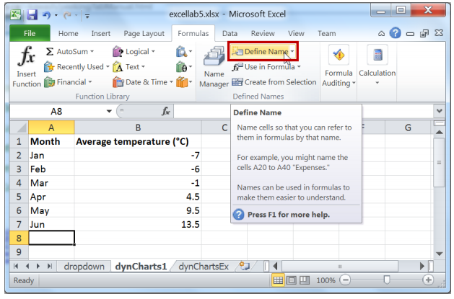

Enter the name, Months. In Refers to, type in the formula that refers to the Months column as shown below. Type carefully. If you want to check if the range you entered is correct, click in the comments field then back in the Refers to field. The range should be highlighted in your worksheet. When you aredone, press OK.

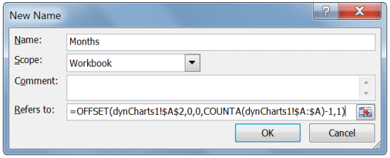

Note that a cell address can be prefixed by the sheet name in which the cell is contained followed by the exclamation mark (!). For instance. dynCharts!$A$2 referes to cell A2 in dynCharts. The address A$2$ is absulote (fixed).

**Exercise 3**

Create a Name (Temps) for the temperature column.

If you need to view or modify the names in your worksheet, click on the Name Manager in the Defined Names group.

Now that our formulas are ready, we can create the chart. In the Insert tab, under the Charts group, select 2D line. Make sure no cells are selected while you are doing this. A blank chart is created. Right-click the chart and click on Select Data.

We now need to decide which column we would like to see on the vertical axis and which we would like on the horizontal one. Let us place the temperatures in the vertical axis.

Click on the Add button under Legend Entries.

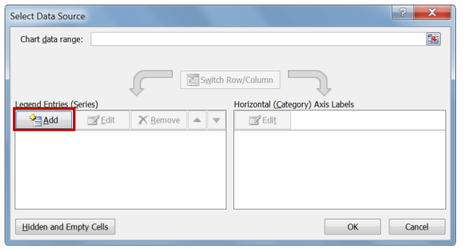

The Series name is the name of the vertical (y) axis values. In this case, it is cell B1. The series values are the Temps formula we created. To refer to this formula, you must first type in the sheet name it was created in, followed by an exclamation mark. Otherwise, Excel will not know where to find this name.

When you are done, press the OK button.

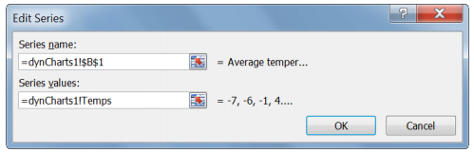

Now press the Edit button under Horizontal (Category) Axis Labels.

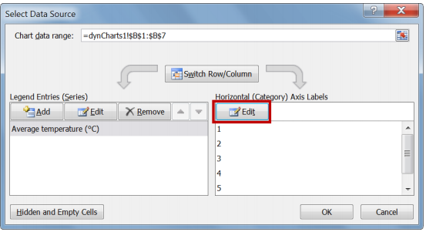

Type in the reference to the Months formula and press the OK button.

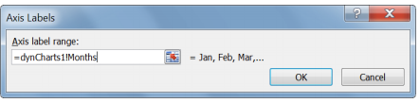

Next, on the Select Data Source dialog box, press the OK button. Your chart should look like this:

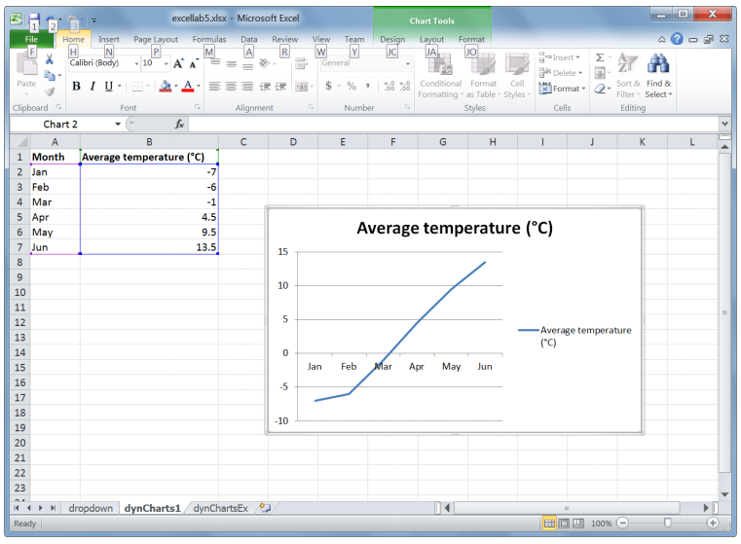

Try adding new data to the table and watch how the chart gets updated.

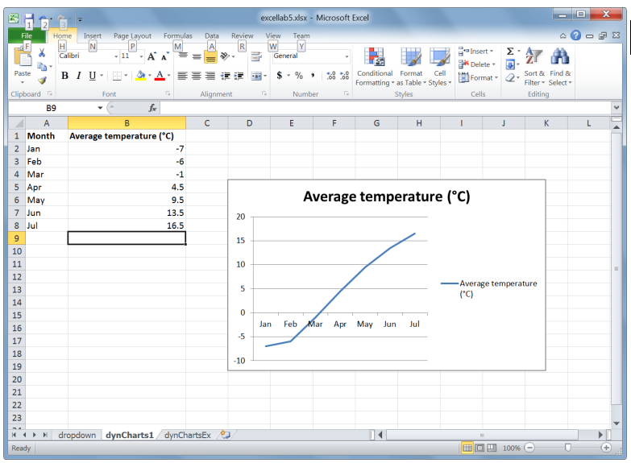

Note that in the dynamic chart we created, because the average temperatures for some months are negative and the x-axis crosses y-axis at the temperature of 0o, the x-axis appears in the middle of the chart. If you want to move the position of the x-axis, open the Format Axis dialog by right-clicking on the y-axis as shown below.

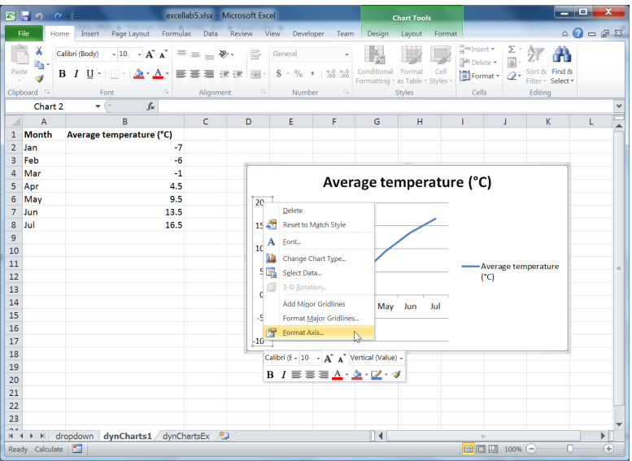

In the Format Axis dialog box that appears, under “Horizontal axis crosses”, enter “Axis value” to be the lowest temperature value along the y-axis, which is –10. Press the Close button when you are done.

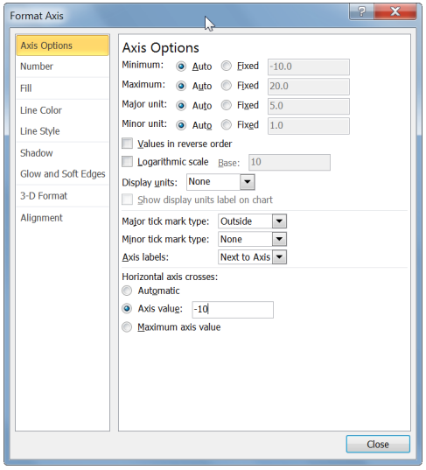

Now the chart will look as follows:

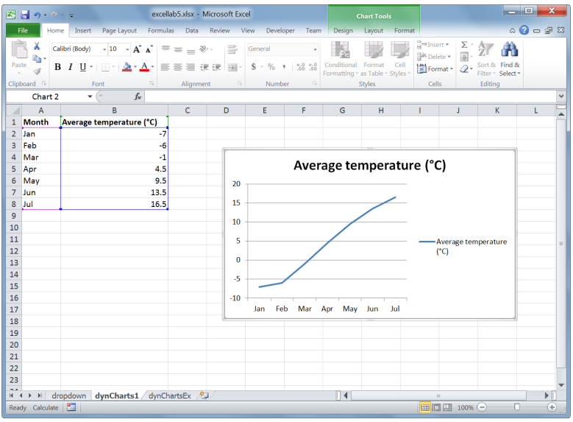

**Exercise 4**

Sheet dynChartsEx shows a table that shows where money is being spent. Create a pie chart whichshows how the money is spent. The chart should be updated automatically whenever a new expense is added.

***LAB 14***

***Introduction to MS Office Excel (Interactive Content)***

**Using combo boxes to create dynamic charts**

Using combo boxes, we can allow users to select which data they would like to see on a chart. First, let us see how we can make a combo box. The difference between the combo box we use in this lab and the one we have seen in the last lab is that this combo box is not used to enter data into cells. It is used to let the user interact with the worksheet as a form.

Open excellab6.xslx and navigate to the comboBox sheet. Under the Developer tab, in the Controls group, press the Insert button, and then select Combo Box from the menu.

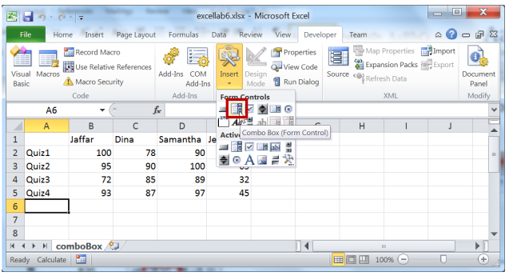

Next, drag the cursor and draw the combo box onto your sheet.

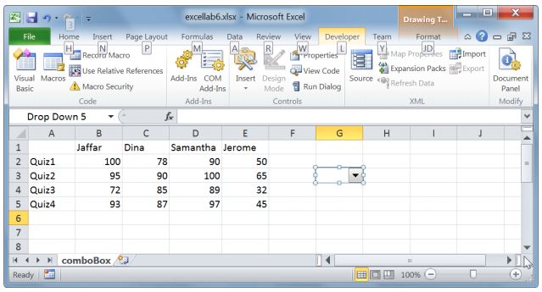

To populate the combo box with data, right-click on the combo box and select Format Control from the menu.

In the control tab, place the cursor in the Input Range field, then select the A2 to A5 from the sheet (or just enter the cell references yourself). The data in these cells will populate the combo box.

The cell link is the cell in which the result of the combo box selection will be displayed. Select any empty cell in the sheet. We are going to select cell I3 as the cell link. When you are done, press the OK button.

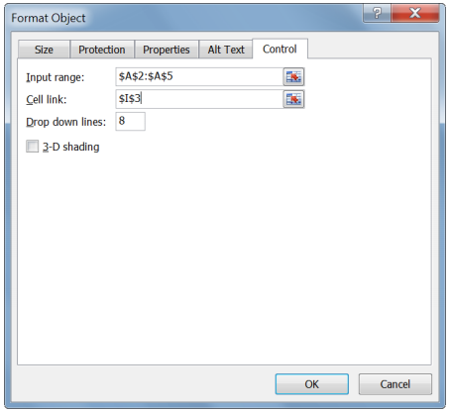

Try the combo box. Notice how cell I3 changes to reflect the index of the selected item in the combo box.

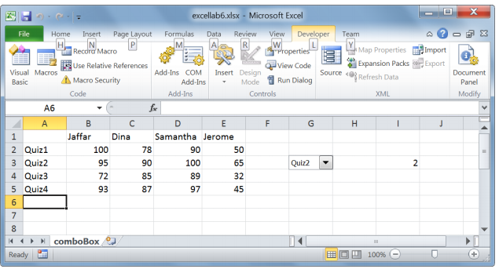

**Exercise 1**

Using names and OFFSET, modify the combo box so that the list of quizzes gets updated whenever anew one is added. Use the name Quizes for your formula.

**Exercise 2**

Create another named variable called SelectedQuiz, which points to the quiz name currently selected in the combo box (hint: use the combo box cell link and OFFSET).

**Exercise 3**

Create a named variable called Students that points to the names of the students in the table. The list should be updated when a new student is added (hint: just like counting cells in a column is done through COUNTA($B:$B), counting cells in a row can be achieved by the formula COUNTA($1:$1)).

**Exercise 4**

Create a named variable called SelectedGrades. This should refer to the array of grades of the selected quiz selected in the combo box.

After you are done with the above exercises, it becomes easy to create the chart. Without any range of cells being selected, create an empty 2D column chart. Right-click the chart and select Data from the menu.

Click on the Add button under the Legend Entries heading.

A good idea for the series name would be the name of the current quiz selected. The series valuesshould be the selected grades. Do not forget to enter the name of the sheet first, as shown below. Click OK when you are done.

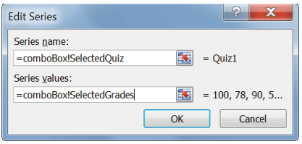

Obviously, the horizontal axis should contain the names of the students. Click the Edit button under the Horizontal (Category) Axis Labels and mention the “Axis label range” as shown below.

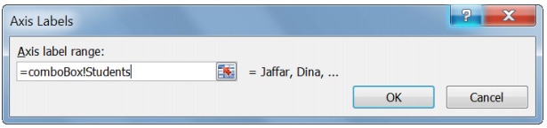

Press the OK button on both dialog boxes when you are done. Now, try changing the selected quiz in the combo box and see how your chart changes.

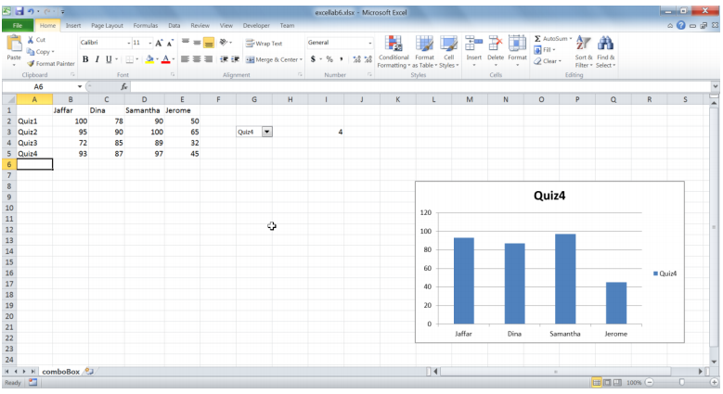

**Using check boxes to create dynamic charts**

Check boxes are a better choice than a combo or list box when we need to select more than one option for our chart. In the Developer tab, under the Controls group, press the Insert button, and select Check Box. It is much more difficult to make a new check box dynamically when you add a new item.

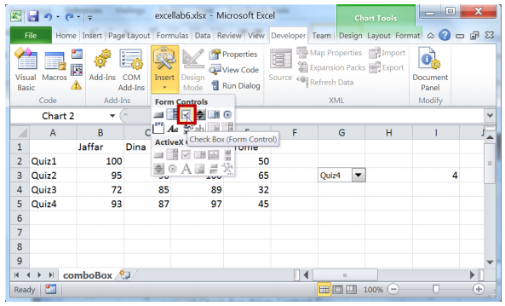

Draw the check box into your sheet. Change the text to Quiz 1. If you need to do this later, right-click the check box and select Edit Text from the menu.

Repeat this three more times, changing the quiz number each time.

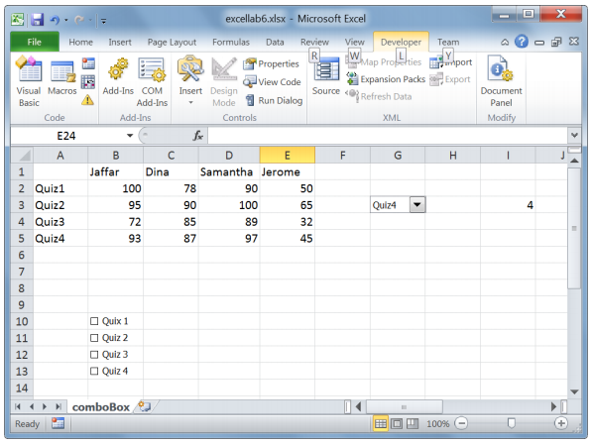

Right-click the 1stcheck box and select Format Control. Just like we did with the combo box control, we need to set the cell link for each check box. This cell will display TRUE or FALSE values, depending on whether the box is checked or not.

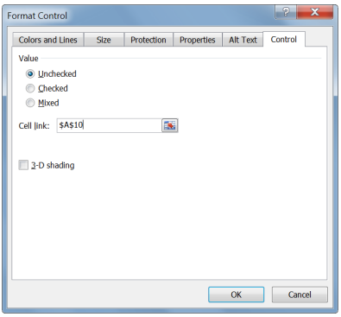

Create cell links for all the other check boxes. Try checking and unchecking the boxes and notice how the cell links change.

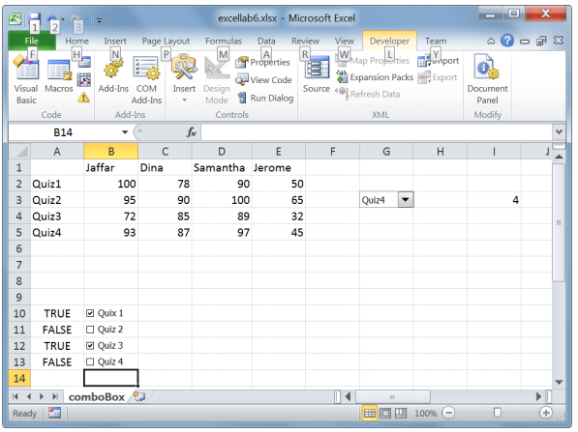

At this point, we need to create a named variable for each of the check boxes. Click on the Define Name button in the Defined Names group under the Formulas tab.

The first formula we are going to enter is for whether or not we need Excel to plot Quiz 1 values.

Obviously, since this requires TRUE/FALSE decision making, we need to use If statements. The if statement shown below checks the cell link for the 1stcheck box, if it is true, it returns the quiz grades for quiz 1, otherwise it returns a 0.

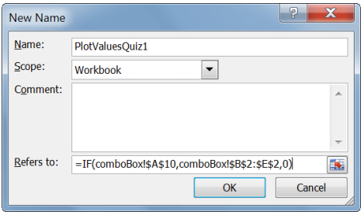

**Exercise 5**

Create named variables for the rest of the check boxes.

We also need to create named variables for the series titles. The if statement returns blank if the box is unchecked.

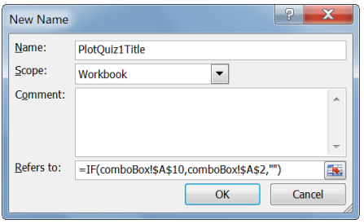

**Exercise 6**

Create named variables for the rest of the series titles.

Insert a blank 2D line chart into your sheet. Just for the time being, make sure all your check boxes are checked; Excel will return error messages otherwise. Right-click on the chart area and click on Select Data. Press the Add button under the Legend Entries header. The series name here is the Quiz 1 title variable. The values are the Quiz 1 values. Remember that both will return blanks or zeroes if the Quiz 1 box is unchecked.

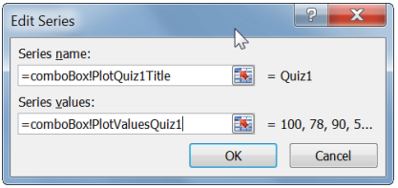

**Exercise 7**

Add 3 more legend entries to the rest of the check boxes. Remember to click the Add (not Edit) button. When you are done, set the Students as the Horizontal Axis Labels.

Following is what your chart should look like:

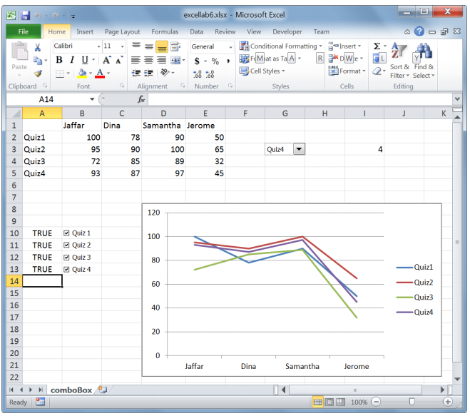

Try unchecking some of the boxes to see how the chart changes.

**What’s next?**

This is only the beginning when it comes to dynamic charts. You can use different controls, such as scroll bars, list boxes or even a combination of many controls. You will need to go beyond what we covered in this lab to master Excel. This lab was only meant to provide you with a starting point.

There are times when it may be more useful to use Data Validation lists rather than the combo boxes we used in this lab. In this case, you can always look up the index of the selected list item using the MATCH function.

Take a look at the chart on this website:

<http://spreadsheetpage.com/index.php/tip/interactive_chart_with_no_macros/>

Remember there are many different ways to create cool and useful charts in Excel. You are only limited by how much you are willing to learn and how much effort you are willing to put in.

***LAB 15***

***Introduction to Pseudo codes and Flow Charts***

***Objectives:***

1. ***After completion of this lab session, you will have gained fundamental skills to plan the logic of a program by ways of developing an algorithm in the form of pseudocode or flowchart.***

**Introduction**

Let us recall that the programming process follows a program development lifecycle with its initial steps as understanding the problem and planning the logic. This session focuses on ‘planning the logic’ where we will learn how to develop an algorithm in the form of pseudo code or flowchart.

Tools/Software Requirement

Visual Logic (http://www.visuallogic.org/download). This software provides a mechanism to draw flowchart which can be executed.

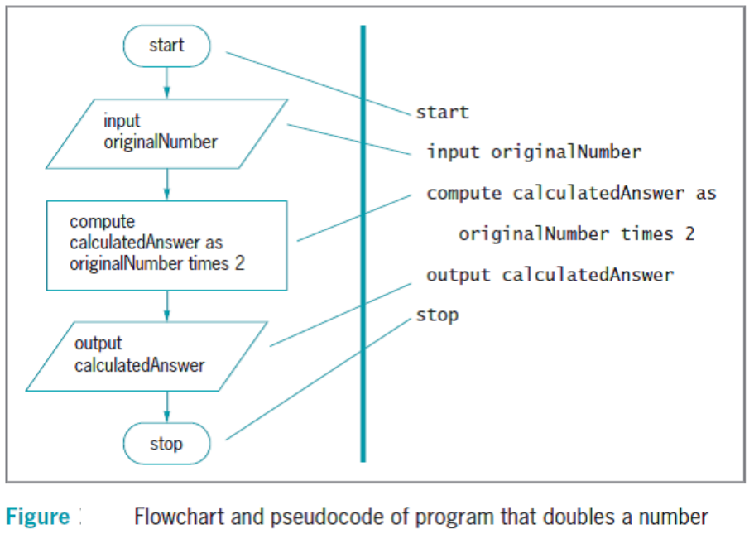

We will be using the Visual Logic tool to draw the flowchart. Below, we see the symbols used by Visual Logic associated to various actions performed in an algorithm. Remember that these shapes are arbitrarily assigned and there is no hard and fast rule about this association. In the case of Visual Logic, you do not need to remember the shape associations as these are created automatically.

How to use Visual Logic? See <http://www.visuallogic.org/Tutorial.html>

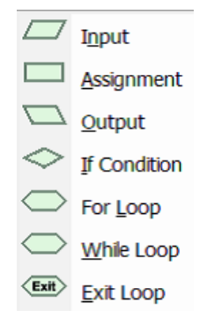

**Exercise 1**

Develop the logic of a program that takes two numbers and display their multiplication and division.

Answer:

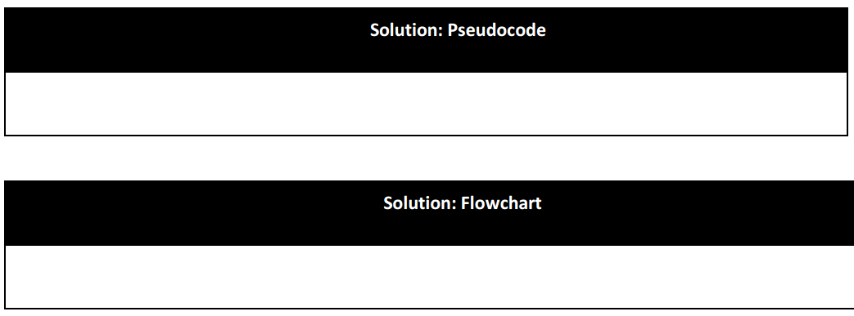

**Exercise 2**

The departmental store manager wants a program that calculates and displays the sale price of a good when its cost price is entered. Sales price is the final price that has 15% of GST added to cost price. Develop the logic of this program**.**

Answer:



**Exercise 3**

Develop the logic of a program that asks the user to enter a number x and calculate the value of polynomial 5x2+3x+8

Answer:



**Exercise 4**

Develop the logic of a program that takes the length, width and height of a room and calculate its volume and total surface area.

Answer:



**Additional Bonus Questions**

**Q1)**Body mass index (BMI) is a statistical measurement that compares a person’s weight and height. To calculate BMI, you multiply your weight in pounds by 703 and divide the result the square of your height in inches. Develop the logic for a BMI calculator.

**Q2)** the payroll clerk at Nosaki Company wants a program that calculates and displays an employee’s gross pay, federal withholding tax (FWT), Social Security and Medicare (FICA) tax, state tax, and net pay. The clerk will enter the hours worked (which is never over 40), hourly pay rate, FWT rate, FICA tax rate, and state income tax rate. Develop the logic of this program.

**Q3)** the manager of the Lakeview Hotel wants a program that calculates and displays a guest’s total bill.Each guest pays a room charge that is based on a per-night rate. For example, if the per-night rate is $100 and the guest stays two nights, the room charge is $200. Customers also may incur a one-time room service charge and a one-time telephone charge. Develop the logic of this program.

1)• Lab Task 2 : Introduction to Operating Systems and MS DOS

• Lab Task 3 :Introduction to MS Office Word

• Lab Task 4 : Introduction to MS Office P

• Lab Task 5 : Introduction to MS Office Excel

• Lab Task 6: Introduction to Pseudo codes and Flow Charts